NIST Special Publication 1500-102

DRAFT Voter Records Interchange Common Data Format Specification
Version 1.0

John P. Wack, editor
Sam Dana
John Dziurlaj
E. John Sebes
Sarah Whitt

This publication is available free of charge from:
http://dx.doi.org/10.6028/NIST.SP.1500-102

NIST Special Publication 1500-102

DRAFT Voter Records Interchange Common Data Format Specification

Version 1.0

John P. Wack, NIST, editor
Sam Dana, Prometheus Computing
John Dziurlaj, Democracy Fund
E. John Sebes, OSET Foundation
Sarah Whitt, Wisconsin Elections Commission

This publication is available free of charge from:
http://dx.doi.org/10.6028/NIST.SP.1500-102

Nov 2017

U. S. Department of Commerce
Wilbur Ross, Secretary

National Institute of Standards and Technology
Walter Copan, Director
National Institute of Standards and Technology (NIST) Special Publication 1500-102
127 pages (November 2017)

NIST Special Publication series 1500 is intended to capture external perspectives related to NIST standards, measurement, and testing-related efforts. These external perspectives can come from industry, academia, government, and others. These reports are intended to document external perspectives and do not necessarily represent official NIST positions.

Certain commercial entities, equipment, or materials may be identified in this document in order to describe an experimental procedure or concept adequately. Such identification is not intended to imply recommendation or endorsement by NIST, nor is it intended to imply that the entities, materials, or equipment are necessarily the best available for the purpose.
There may be references in this publication to other publications currently under development by NIST in accordance with its assigned statutory responsibilities. The information in this publication, including concepts and methodologies, may be used by federal agencies even before the completion of such companion publications. Thus, until each publication is completed, current requirements, guidelines, and procedures, where they exist, remain operative. For planning and transition purposes, federal agencies may wish to closely follow the development of these new publications by NIST.
Organizations are encouraged to review all draft publications during public comment periods and provide feedback to NIST. All NIST publications are available at http://www.nist.gov/publication-portal.cfm.

National Institute of Standards and Technology
Attn: Software and Systems Division, Information Technology Laboratory
100 Bureau Drive (Mail Stop 8970) Gaithersburg, MD 20899-8930
Email: voting@nist.gov

Reports on Computer Systems Technology
The Information Technology Laboratory (ITL) at the National Institute of Standards and Technology (NIST) promotes the U.S. economy and public welfare by providing technical leadership for the Nation’s measurement and standards infrastructure. ITL develops tests, test methods, reference data, proof of concept implementations, and technical analyses to advance the development and productive use of information technology. This document reports on ITL’s research, guidance, and outreach efforts in Information Technology and its collaborative activities with industry, government, and academic organizations.

Abstract
This document presents a specification for voter records data interchange related to voter registration, i.e., registration requests from online voter registration made to voter registration systems, and responses to the requests returning from the voter registration system. The specification includes XML (eXtensible Markup Language) and JSON (JavaScript Object Notation) schemas.

Keywords
Common data format (CDF); FPCA; JSON; NVRA; voter registration; VVSG; XML.

Acknowledgements

The editor wishes to thank his colleagues of the National Institute of Standards and Technology Voter Records Interchange Public Working Group, who contributed to its technical content. The editor gratefully acknowledges and appreciates the following contributors for their keen and insightful assistance with developing this specification:

Kim Brace  Election Data Services, Inc. | Thomas Connolly  NY State Board of Elections | Monica Crane-Childers  Democracy Works
Gema Howell  National Institute of Standards and Technology | Ericka Haas  ERIC for the States | Christopher Jerdonek  San Francisco Elections Commission
Benjamin Long  National Institute of Standards and Technology | Jared Marcotte  The Turnout | Lauren Massa-Lochridge
John McCarthy  Verified Voting | Janet Modrow  Florida Division of Elections | Katy Owens Hubler  Democracy Research, LLC
Tammy Patrick  Democracy Fund | Jen Tolentino  Rock the Vote | David Wallick  Everyone Counts
Stafford Ward
U.S. Vote Foundation
In addition to the above acknowledgments, the editor also gratefully acknowledges and appreciates the significant contributions from individuals and organizations involved in the NIST Voting Interoperability Public Working Group as well as in the public and private sectors, whose thoughtful and constructive comments improved the overall quality, thoroughness, and usefulness of this publication.

Executive Summary

Online voter registration (OVR) systems generally involve the exchange of voter registration data between a registration portal such as the MVA/DMV in which a voter is offered the opportunity to register to vote, and a voter registration (VR) authority that is associated with the state/territory and its VR system. In some cases, third-party OVR assistant organizations that assist voters in registration can also exchange this information with the VR authority.

However, the data exchanged is generally in a non-uniform format, which causes a number of complications in that each state/territory or sometimes each individual portal application may have its own format that must be interpreted and translated on the receiving end. Voter addresses, in particular, are often provided to VR authorities in formats that are difficult to efficiently store in voter registration databases and subsequently used in various related applications. Each OVR application being developed must then be aware of each state’s specific formats or design its own format, which complicates development and inhibits the implementation of OVR.

The purpose of this specification is to assist election officials and developers in more easily implementing and supporting the development of OVR systems by providing to them a uniform common data format for voter records interchange (VRI), that is, the voter registration requests and responses needed for OVR. The languages used in the common data format are XML (eXtensible Markup Language) and JSON (JavaScript Object Notation).

The advantages of using this specification include:

- Providing a ready data interchange format for online voter registration systems to remove the need for individual OVR system development projects to define their own data models and formats.
- Assisting election officials by reducing or eliminating non-standard exchange formats for voter registration data.
- Providing a baseline CDF (common data format) for voter registration data that can be continually refined to be more efficient and adaptable across all states.
- Providing the foundation for additional use cases in the future, which could include matching driver’s license data between the MVA/DMV and OVR systems, automated notifications between the DMV and OVR systems, cross-state record matching, or facilitating data reporting for the Election Administration and Voting Survey (EAVS).

This specification provides background and explanation of how online voter registration typically works, using the data required by the National Voter Registration Act (NVRA) and Federal Post Card Application (FPCA) voter registration forms, including state-specific additions to these forms. It then contains an explanation of a UML (Unified Markup Language) model that was created to detail the data elements required in voter registration requests and responses. The UML model was used to generate XML and JSON schemas, which are both explained and used in various implementation examples.

The intended audience of this specification includes election officials, VR system designers and developers, as well as others in the election community including the general public. Some background in election administration and registration is useful in understanding the material in this specification.

Table of Contents
Executive Summary 4
1 Introduction 9
1.1 Purpose 9
1.2 Audience 10
1.3 Motivation and Methodology 10
2 Overview of Digital OVR Transactions 12
2.1 Voter Records Request 14
2.2 Voter Records Response 18
2.3 Including State-specific Request and Response Items 20
2.4 Dealing with Addresses - The U.S. Thoroughfare, Landmark, and Postal Address Data Standard 20
2.4.1 Thoroughfare Classes 23
2.4.2 Landmark Classes 23
2.4.3 Postal Delivery Classes 24
2.4.4 General Address Class and Handling Non-U.S. Addresses 24
3 XML Schema Documentation 26
3.1 Schema Stylistic Conventions 26
3.2 Roots 26
3.3 Imports 27
3.4 Interfaces 27
3.5 Enumerations 28
3.5.1 The AssertionValue Enumeration 28
3.5.2 The BallotReceiptMethod Enumeration 29
3.5.3 The ContactMethodType Enumeration 30
3.5.4 The IdentifierType Enumeration 31
3.5.5 The PhoneCapability Enumeration 32
3.5.6 The RegistrationError Enumeration 33
3.5.7 The RegistrationForm Enumeration 34
3.5.8 The RegistrationHelperType Enumeration 35
3.5.9 The RegistrationMethod Enumeration 36
3.5.10 The RegistrationProxy Enumeration 38
3.5.11 The RegistrationRequestType Enumeration 39
3.5.12 The ReportingUnitType Enumeration 40
3.5.13 The SignatureSource Enumeration 42
3.5.14 The SignatureType Enumeration 43
3.5.15 The SuccessAction Enumeration 44
3.5.16 The VoterClassificationType Enumeration 45
3.5.17 The VoterIdType Enumeration 47
3.6 Classes (Elements) 48
3.6.1 The <AdditionalInfo> Element 48
3.6.2 The <ContactMethod> Element/Extension Base 50
3.6.3 The <ElectionAdministration> Element 53
3.6.4 The <ExternalIdentifier> Element 54
3.6.5 The <File> Element/Extension Base 55
3.6.6 The <LatLng> Element 57
3.6.7 The <Location> Element 58
3.6.8 The <Name> (<PreviousName>) Element 59
3.6.9 The <Party> Element 61
3.6.10 The <RegistrationHelper> Element 62
3.6.11 The <RegistrationProxy> Element 63
3.6.12 The ReportingUnit Element 65
3.6.13 The <Signature> (<PreviousSignature>) Element 66
3.6.14 The <VoterClassification> Element 67
3.6.15 The <VoterId> Element 69
3.6.16 The <VoterRecordsRequest> Element 71
3.6.17 The <VoterRecordsResponse> Element/Extension Base 73
3.6.18 The <VoterRegistration> Element 77
4 XML and JSON Usage Examples 81
4.1 Example 1: NVRA-style Voter Registration Request in XML 81
4.2 Example 2: NVRA-style Voter Registration Request in JSON 85
4.3 Example 3: NVRA-style Voter Records Response in XML 89

List of Appendices
Appendix A— Acronyms 91
Appendix B— Glossary 92
Appendix C— References 93
Appendix D— File Download Locations 94
Appendix E— XML Schema 95
Appendix F— JSON Schema 105

List of Figures

Figure 1 - National Voter Registration Act (NVRA) form 12
Figure 2 - Federal Post Card Application (FPCA) form 13
Figure 3 - Voter Registration Use Case 14
Figure 4 - Voter Records Request UML Class Diagram 16
Figure 5 - Voter Records Request UML Enumerations 17
Figure 6 - Voter Records Response UML Class Diagram 19
Figure 6 - FGDC Address Types Mapped to Single Address Attribute 22
Figure 8 - Example NVRA-style form for a voter address update request 81
Figure 9 - Example NVRA-style form for a voter registration request 85
Figure 10 - Populated NVRA voter registration response form 89

Introduction
This document is a specification for a common data format (CDF) for voter records data interchange related to voter registration, i.e., registration requests from online voter registration (OVR) made to voter registration (VR) systems, and responses to the requests returning from the VR system. The specification includes XML (eXtensible Markup Language) [1] and JSON (JavaScript Object Notation) [2] schemas.
The primary features of this specification include:
- A data format for voter registration requests and responses when using the NVRA (National Voter Registration Act) [3] or FPCA (Federal Post Card Application) [4] forms and state-specific variations on them.
- A data model in UML (Unified Modeling Language) [5] that itemizes and defines the data involved in voter records interchange related to registration and that is used to derive the XML and JSON schemas.
- Detailed instructions for implementation and use of the XML and JSON schemas.
- A flexible specification to cover additional use cases for other types of registration transactions, such as for voter record maintenance.

Purpose
The purpose of this specification is to provide data interchange formats in XML and JSON for voter registration requests and responses so as to assist election officials and developers in implementing and supporting the development of OVR systems within States. Advantages of using this specification include:

- Providing a ready data interchange format for online voter registration systems so as to remove the need for individual OVR system development projects to define data models and formats or adapt to other formats specific to States.
- Assisting election officials by reducing or eliminating non-standard exchange formats for voter registration data. The current varying systems involved and data produced often do not interoperate, adding more complexity to the process.
- Providing a baseline CDF that can be continually refined. Once jurisdictions adopt the CDF VRI, their experience and feedback will refine the continued development of the specification.
- Providing the foundation for additional use cases in the future, which could include matching driver’s license data between the DMV and OVR systems, automated notifications between the DMV and OVR systems, cross-state record matching, or facilitating data reporting for the Election Administration and Voting Survey (EAVS).

Audience
The intended audience of this specification includes election officials, VR system designers and developers, as well as others in the election community including the general public. Some background in election administration and registration is useful in understanding the material in this specification.

Motivation and Methodology
This document was motivated primarily to assist election officials and developers in implementing and supporting OVR systems by reducing or eliminating non-standard exchange formats for voter registration data. The current varying systems involved and data produced often do not interoperate, adding more complexity to the process. Additionally, there are sometimes significant variations among different jurisdictions within a state as well among the states themselves in the way they automate voter registration and related parts of voter record management.

NIST and a community of U.S. election officials, analysts, and election system technologists analyzed varying VR scenarios and use cases and their associated data interchanges, to analyze existing practices and to create a standard data interchange format for emerging OVR systems. This specification implements the following use cases:

- OVR Submission: Digital VR applications forms transmitted within state OVR systems or to state OVR systems by third-party OVR systems, following the formats of the NVRA and FPCA voter registration application forms, including state-specific additions to these forms.
- VR Update Submission: Similar application forms including: voter registration update (change of name, change of address), change of voter status, and absentee ballot request.
- OVR Transfer: Subsets of such applications used for third-party OVR assistant organizations to transfer users and user data to state OVR systems.
A UML data model was subsequently generated to represent the data associated with OVR requests and responses and to show how the data elements are related and organized. Finally, XML and JSON schemas were generated from the UML data model.

The advantages of using a UML data model as an intermediate step to generating the XML and JSON schemas include that the model is independent of the concrete data formats (or other potential formats that could be derived), and relationships between data elements are easier to correctly define and visualize when they are independent of any specific data format. If changes are needed to the specific XML and JSON formats, one can make changes to the UML model and then generate or derive new versions of the formats.

Much of the data involved in voter registration requests consists of voter addresses: current registration addresses, postal addresses, previous registration addresses, etc. Rather than implement new and complicated functionality in this specification for representing addresses, it was decided to use the existing U.S. Thoroughfare, Landmark, and Postal Address Data Standard [6] which contains four major classes of addresses that are broken out into 11 different types of addresses. These can be used to represent addresses where voters live and where they receive postal mail (if different), including overseas addresses.

While this specification is focused on digital OVR submission, subsequent versions of this specification may implement additional use cases, including:

- DMV Match: Subsets of such digital applications exchanged between state VR systems and DMV (Department of Motor Vehicles) or similar systems, to perform driver's license data matching (if required) as part of OVR processing.
- DMV Notification: Data exchanged by DMV (Department of Motor Vehicles) or similar systems and VR systems, as part of NVRA compliance to digitally notify VR systems of DMV records of DMV customers that requested voter registration. May also include: similar data push from DMV of existing DMV records recently updated with change-of-address, as part of semi-automated steps toward permanent voter registration, or other forms of data exchange to VR systems that might facilitate elements of automatic and/or permanent voter registration.
- Cross-State Records Match: Data interchange between state VR systems and systems for records matching, e.g., the ERIC (Electronic Registration Information Center) [7].
- EAVS Submission: Subsets of voter records externalized from voter records systems for purposes of data aggregation and reporting, including but not limited to EAVS (Election Administration Voting Survey) [8] reporting.
Note that this specification addresses U.S. governmental elections and is not intended for use “as is” in other types of elections or in other countries. However, the specification was written with the intention that it be adaptable to other election environments.

Overview of Digital OVR Transactions
This section presents an overview of the digital OVR voter registration transactions supported by this specification and examples of how they are implemented using the NVRA and FPCA forms (shown in Figures 1 and 2) as well as with state-specific forms, e.g., modifications to the NVRA. It also contains an overview of the U.S. Thoroughfare, Landmark, and Postal Address data standard [6] used by this specification for representing voter addresses.

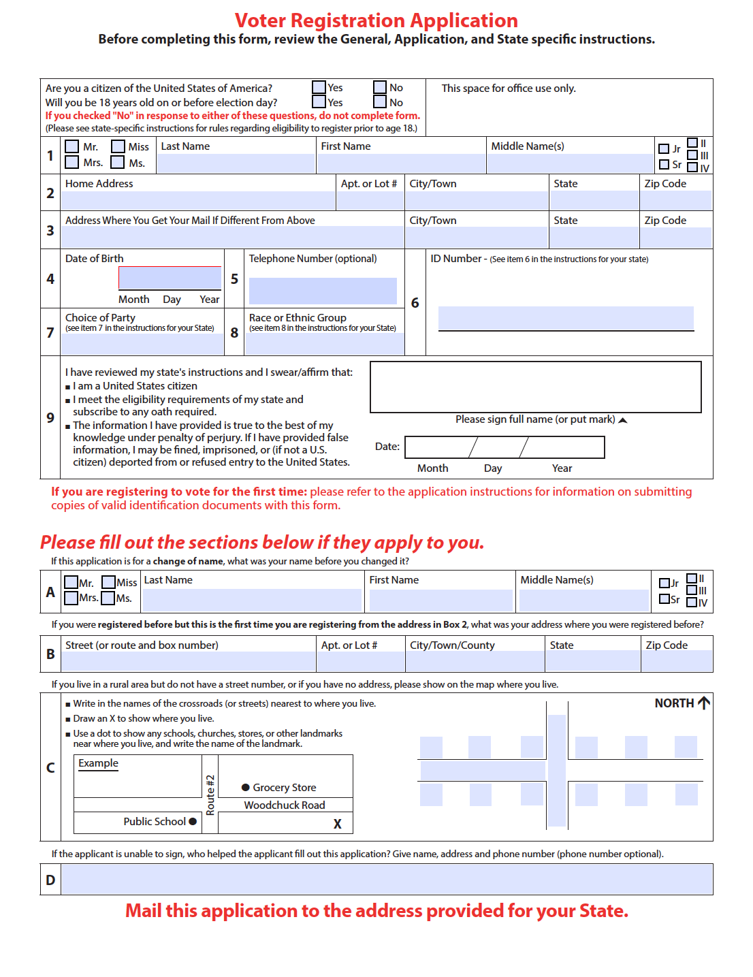
Figure 1 - National Voter Registration Act (NVRA) form
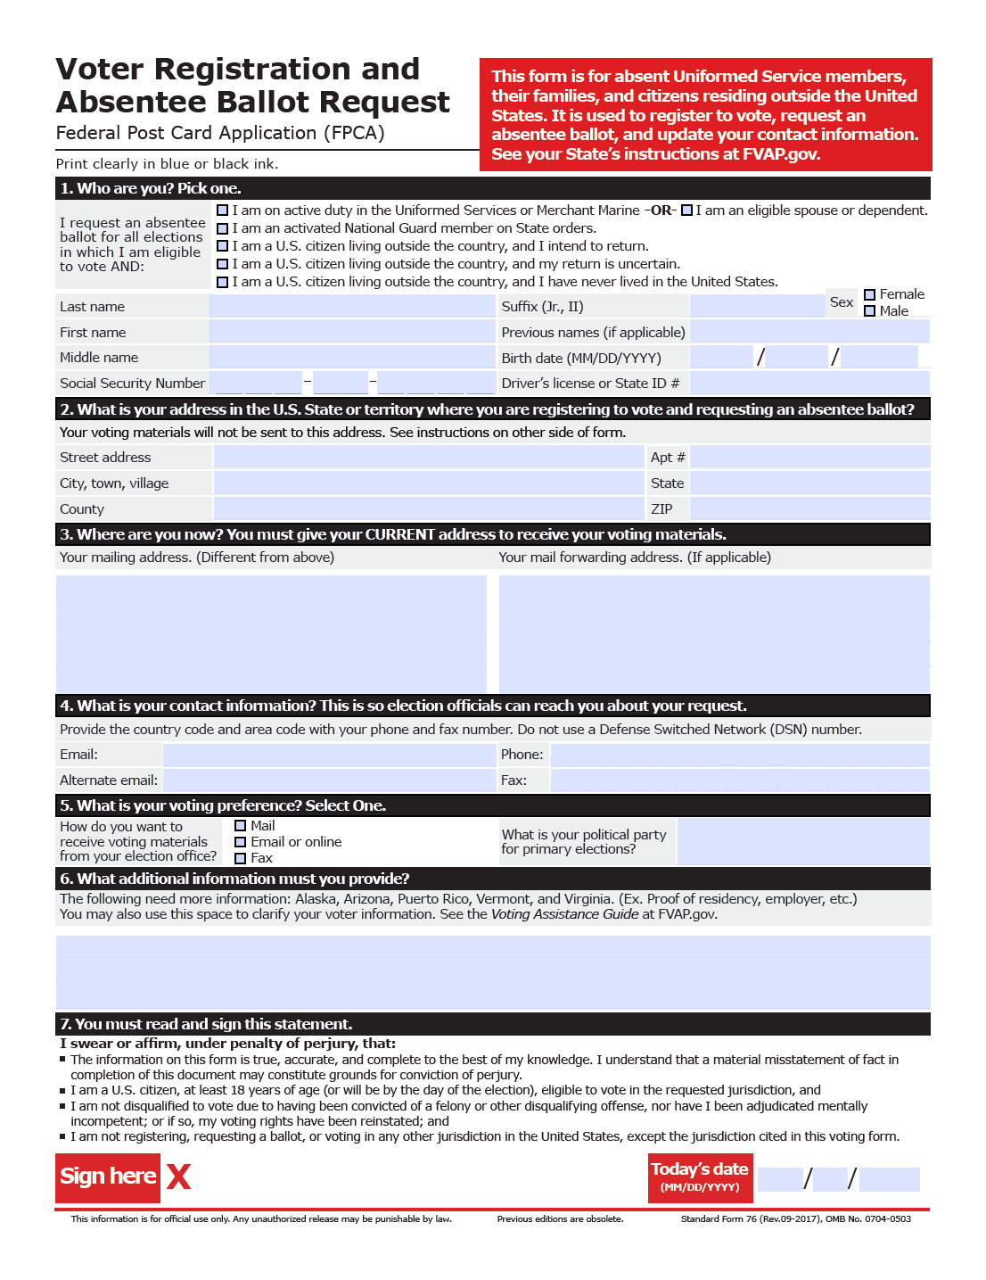
Figure 2 - Federal Post Card Application (FPCA) form

The forms shown in Figures 1 and 2 are paper-based, whereas states implementing OVR make digital representations of the forms, usually with some state-specific modifications that may request additional data.

Voter Records Request
The digital NVRA and FPCA forms form the basis for digital OVR registration. The NVRA form is used for U.S. non-military citizen registrations whereas the FPCA form is used by U.S. military, their families, and citizens residing outside the U.S. to register and, if desired, request a ballot at the same time.

The submission of a digital registration form to a VR authority represents a voter records request. The response transmitted back from the VR authority to the submitter includes a status such as "registration-created" or would indicate an error for reasons including “incomplete-address” or “incomplete-signature”. The request consists of a registration request, e.g., initial registration, followed by various information about the voter and the submitter of the request.

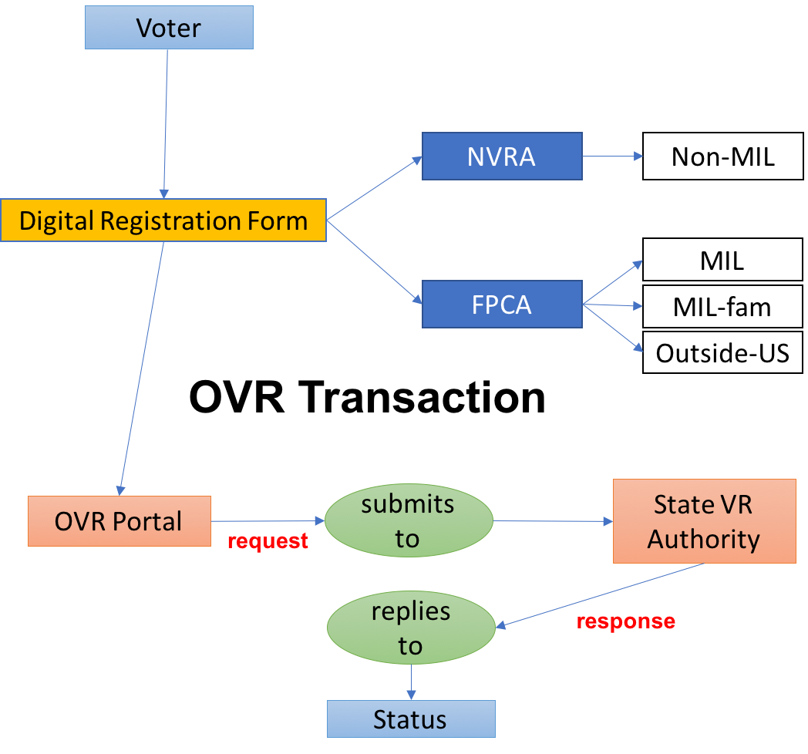
Figure 3 - Voter Registration Use Case

The use case for the digital OVR request, shown in Figure 3, includes:

- A client IT “OVR submitter”,
- A service IT system “VR authority”, and
- The submission a digital NVRA, FPCA, or otherwise state-specific form via transmission from OVR submitter to VR authority.
Currently, VR authorities are typically the back-end components of actual state OVR systems, while submitters include clients of state OVR systems such as the DMV/MVA or other clients that are operated by third-party VR organizations and that integrate with OVR systems by sending all or part of an NVRA/FPCA dataset collected by the client from a human registrant.

An OVR transaction, as used in this specification, generally consists of a voter records request followed by a voter records response, although this may vary across U.S. states and territories. The request can consist of multiple requests if multiple actions are being requested for the same voter. As well, the response could consist of multiple responses.

The voter records request UML model in Figures 4 and 5 include three types of requests that could be sent from an OVR submitter to a VR system (see the RegistrationRequestType enumeration in Figure 5):

- Request a registration for a voter using the digital NVRA or FPCA form.
- In the case of a registration request using the FPCA form, also request a ballot for an election (FPCA registrations can include a ballot request).
- Request a state-specific action for a voter using possibly a state-specific digital form.
The VoterRegistration class is the primary class; it contains information about the voter, including name, addresses, party registration, voter’s signature, method of contact, etc. If a third-party registration assistant or proxy is being used, the RegistrationHelper or RegistrationProxy classes are used to include name and other information generally required by the registration forms.

Both the registration request and response models contain a class ExternalIdentifier, which is used to associate an identifier with an item. In the case of the request model, it is used optionally to associate an identifier to the political party, and in the response model, to optionally associate identifiers with political geography such as precincts and districts. The enumerations often contain a value of Other, which is to be used when none of the enumeration values apply, and classes that use these enumerations generally contain an OtherType or similarly-named attribute to contain that value. For example, in the ContactMethod class, if none of the enumeration values of ContactMethodType apply, Other would be used in the Type attribute, and the OtherType attribute would contain the value.

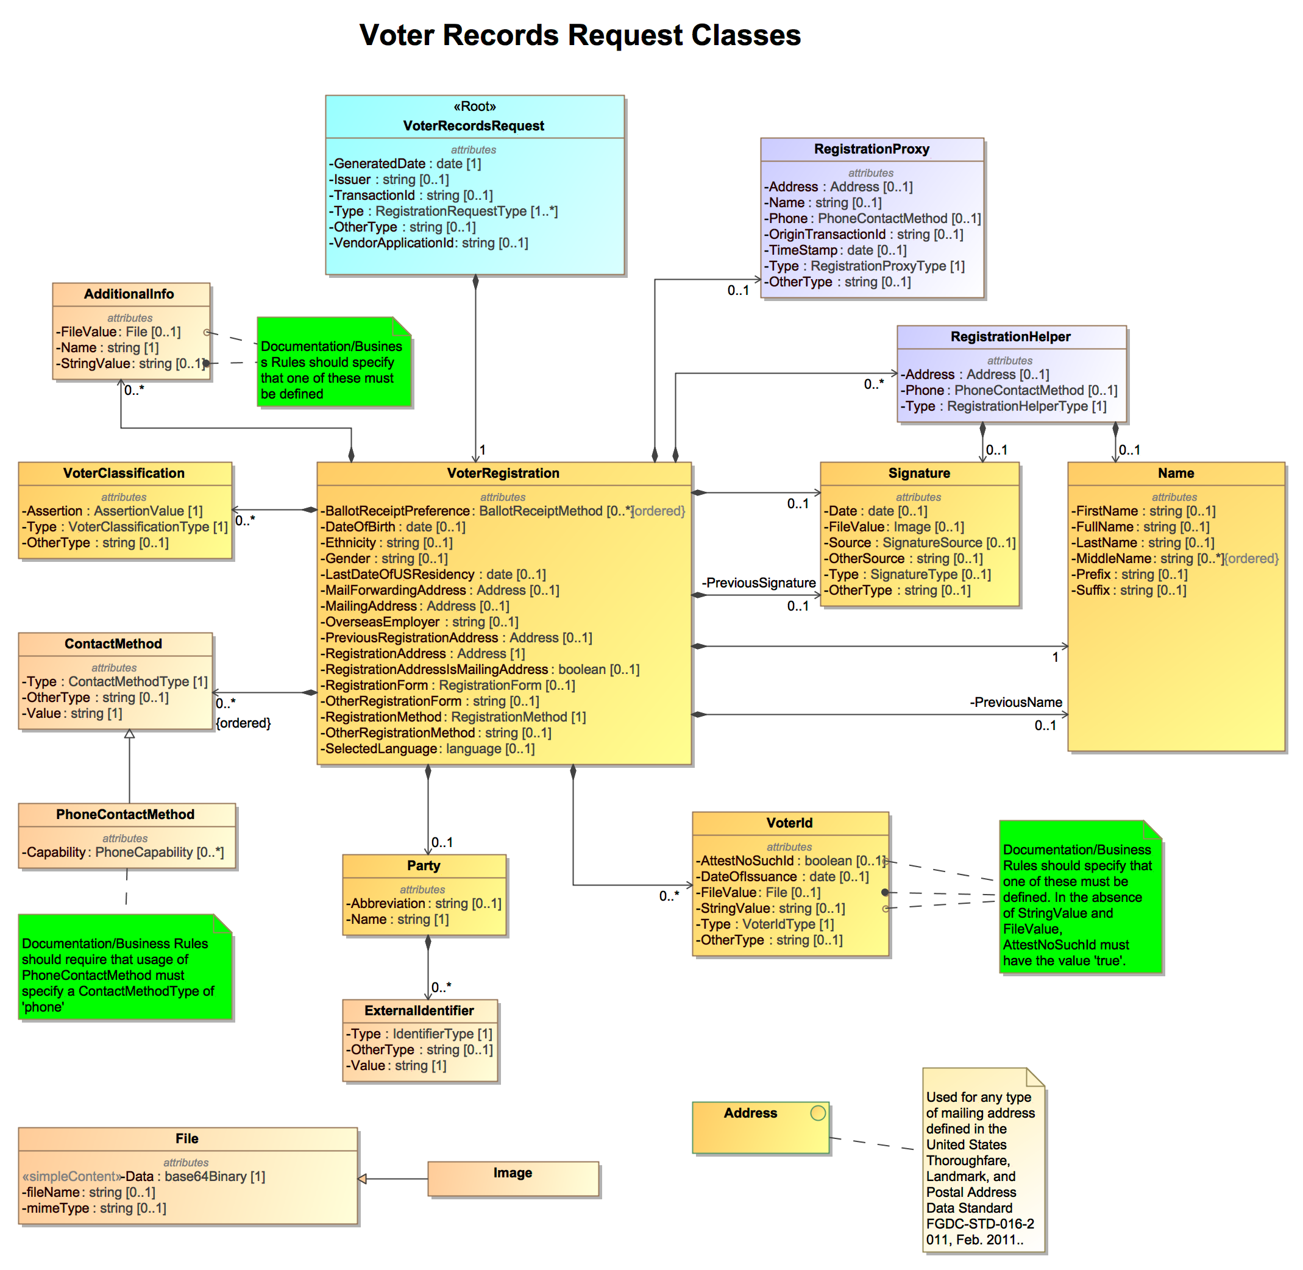

Figure 4 - Voter Records Request UML Class Diagram
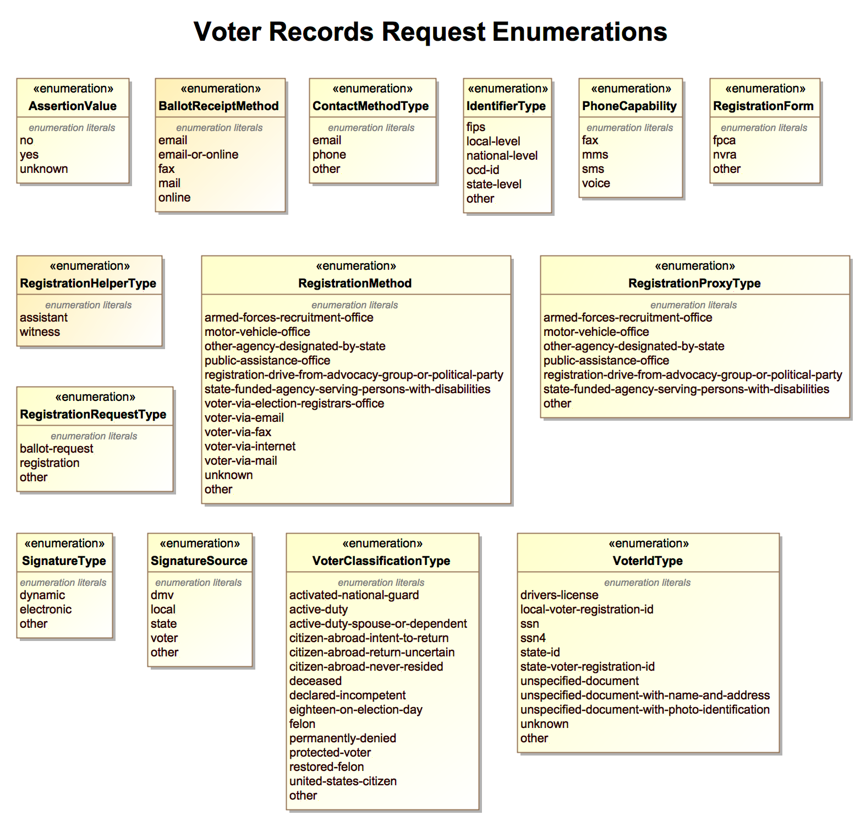

Figure 5 - Voter Records Request UML Enumerations

Voter Records Response
The voter records response simply returns a response to the voter records request. The UML model is simpler than the request model in that a response generally contains little data other
than the results of the request, which are:

- The registration request was acknowledged, but no further status is available.
- The registration request was rejected, including a reason(s) for the rejection.
- The registration request succeeded, including the action(s) taken.
The UML model in Figure 5 shows the VoterRecordsResponse class, which has three corresponding types of responses. The first, RegistrationAcknowledgement, represents the typical current practice in online voter registration, where a registration authority operates an online service that receives VR requests and saves them for later processing by local elections offices' staff. In this typical practice, the acceptance of an online VR request is simply an acknowledgement that the request was received without error.

The second type of response, RegistrationRejection, contains the reason(s) for the error that is causing the rejection as well as any additional details. While the various errors that can occur are beyond the scope of this specification, the RegistrationError enumeration lists a series of common errors, including:

- The request is incomplete in some way including incomplete address or name or birthdate or signatures.
- A lookup of the voter’s identity failed.
- The voter is ineligible to vote.

If none of the errors in the enumeration are appropriate, a different error can be specified in the OtherError attribute.

The third type of response, RegistrationSuccess, is used for cases where the receiving service is able to process a request to success and notify the sender synchronously. The contents of a RegistrationSuccess are modeled on the information that becomes available to a newly registered voter as a result of successful registration.

In the UML model, the RegistrationSuccess class optionally includes these items: voter’s assigned polling place and precinct, the location of the local election authority, and a list of districts that the voter resides in, and if available, a list of ballot items in an upcoming election that the voter is eligible to vote in. The successful registration also returns the registration action(s) that occurred, which may differ from what was requested. For example, a request for a new voter registration may succeed, but if the voter was already registered, the response may indicate a registration update as opposed to a registration create.

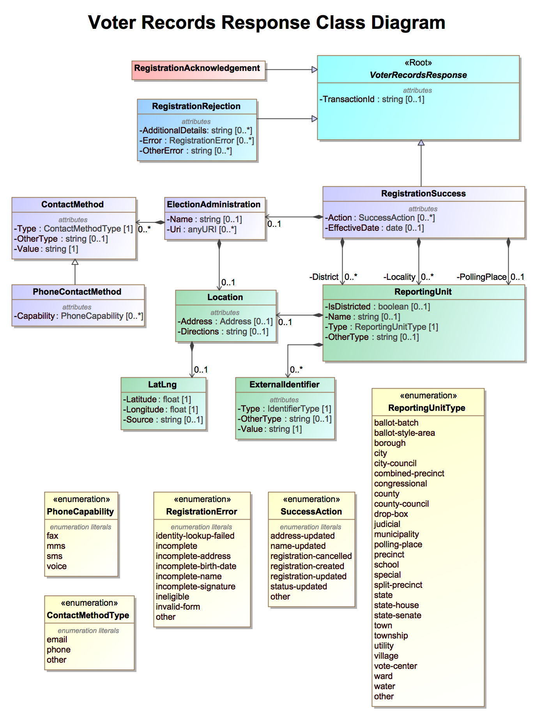
Figure 6 - Voter Records Response UML Class Diagram

Including State-specific Request and Response Items
The UML model and associated XML and JSON schemas contain several features to enable state-specific requests and responses. Using these features, it is possible to use this specification as local modifications are needed.

The AdditionalInfo class is used for information not addressed in this schema by other attributes, e.g., state-specific data that does not "fit" in any other attribute. The type of data will thus be highly specific to the generating application, and consuming applications must "know" the meaning of the data to make use of it. Each AdditionalInfo class would contain the name of the data, and then its value, depending on whether the data represents the value directly as a string or represents a file name.

For example, if a state requires its registration form to include the voter's language, it would need to use the AdditionalInfo class to contain a value representing the voter's language. An XML example is as follows, using English as the voter's language:

<AdditionalInfo>
<Name>Language</Name>
<StringValue>en-US</StringValue>
</AdditionalInfo>

The XML and JSON usage examples in Section 4 contain a number of examples showing usage of the AdditionalInfo class.

Additionally, each enumeration generally contains an "other" value that can be used when none of the enumeration values are sufficient. If "other" is used as the enumeration value, there is an attribute named OtherType that can be used to hold the other data. For example, a state may wish to implement a specific "address-update" transaction, and would thus need to use "other" for the Type attribute in the VoterRecordsRequest class. The OtherType attribute would then contain the type of registration request, i.e., "address-update", e.g. in XML,

<VoterRecordsRequest xmlns:xsd="http://www.w3.org/2001/XMLSchema" ... >
<GeneratedDate>2017-02-10</GeneratedDate>
<Issuer>Ohio Secretary of State</Issuer>
<TransactionId>2a642eb5-169e-4a3b-8899-adc7ea6d00d0</TransactionId>
<Type>other</Type>
<OtherType>address-update</OtherType>
...

Dealing with Addresses - The U.S. Thoroughfare, Landmark, and Postal Address Data Standard
Voter addresses are perhaps the most complex part of a voter registration request or other related data exchanges. As you will see in the examples in this specification, the vast majority of the data in a voter registration request has to do with voter addresses. There are multiple types of voter addresses for VR purposes, e.g.,

- Current registration address,
- Previous registration address,
- Multiple types of addresses for location and mailing purposes, e.g.,
  - Postal mailing address,
  - Structured and unstructured street address,
  - Rural addresses,
  - PO box addresses,
  - Military and diplomatic addresses, and
  - Mailing addresses outside the U.S.
Rather than “re-inventing the wheel” by specifying an address format, this specification makes use of an existing XML-based standard for structuring addresses: the U.S. Thoroughfare, Landmark, and Postal Address Data Standard [6] issued by the Federal Geographic Data Committee (FGDC) [9] and covering the complexity of addresses managed by or encountered by organizations and agencies such as the United States Census and USPS (U.S. Postal Service). Use of the FGDC standard greatly simplifies this specification and leaves maintenance of the standard to a more appropriate management body.

A complete overview of the FGDC standard and how to use it is beyond the scope of this specification, and readers and developers are encouraged to refer to the FGDC standard documentation [6]. Briefly, the FGDC standard classifies all U.S. addresses into a simple taxonomy of address classes organized into 4 groups:

- Thoroughfare Classes - 5 address types,
- Landmark Classes - 2 address types,
- Postal Deliver Classes - 3 address types, and
- General Class - 1 address type.
Altogether, there are a total of 11 address types (most are Thoroughfare types, see section 2.4.1 below).

This specification includes the following types of voter addresses:

- RegistrationAddress,
- PreviousRegistrationAddress,
- MailingAddress, and
- MailForwardingAddress.
To deal with multiple types of voter addresses in a consistent manner, the XML and JSON schemas generated from the UML model map the <Address> type to one of the 11 different address types in the FGDC schema, as shown in Figure 7. Note that a namespace prefix of addr is used for XML types corresponding to the 11 FGDC address types; addr_type is also used for other address component types that are defined in a schema included by the FGDC schema (shown in other examples in this specification).

Because the FGDC standard is in XML only, a corresponding JSON version of the standard had to be created; the JSON version follows closely the XML version.

Figure 7 - FGDC Address Types Mapped to Single Address Attribute
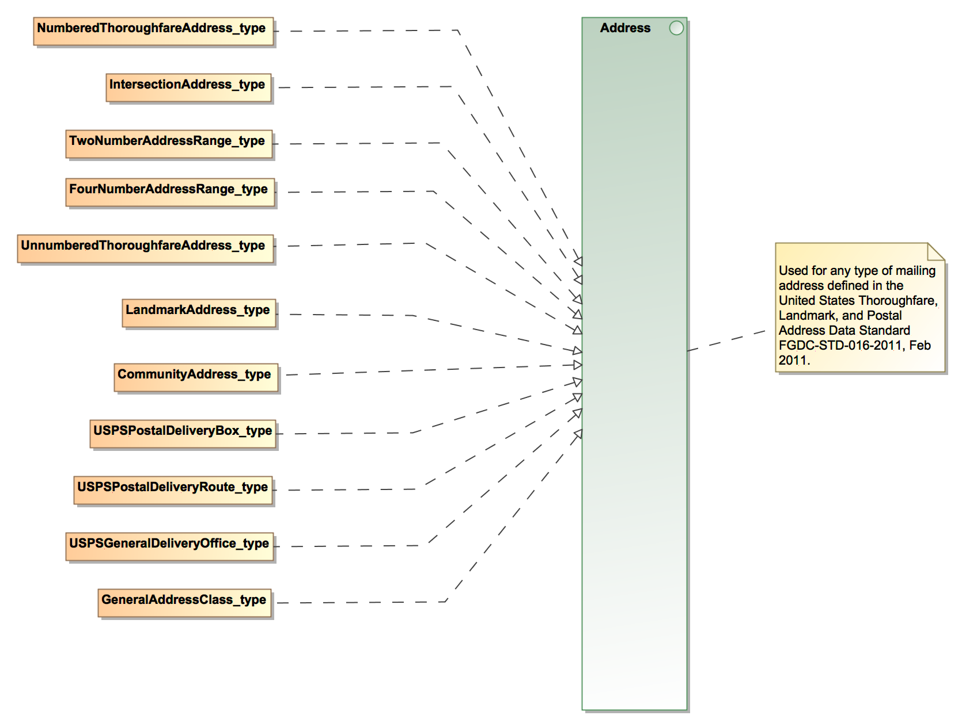

The following sections contain brief overviews of each of the address classes and their types.

Thoroughfare Classes
Most business and residential addresses are Thoroughfare addresses, therefore this class will be used most often. It specifies a location by reference to a thoroughfare, i.e., a road or part of a road or other access route along which a delivery point can be accessed. A thoroughfare is typically but not always a road - it may be, for example, a walkway, a railroad, or a river. The thoroughfare address types are:

- Numbered Thoroughfare Address, e.g., 123 Main Street.
- Intersection Address, e.g., Fifth Avenue and Main Street.
- Two Number Address Range, e.g., 405-411 West Green Street.
- Four Number Address Range, e.g., 900-962, 901-963 Milton Street.
- Unnumbered Thoroughfare Address, e.g., Forest Service Road 698.
Of the 5 types listed, Thoroughfare Addresses are generally used most often. Unnumbered Thoroughfare Addresses are also used for those areas where no address numbers have been assigned and the addresses often include only the thoroughfare name. A simple XML example showing the Numbered Thoroughfare type used in the <MailingAddress> element for “500 W Tuscarawas Ave, Barberton, OH 44203” is as follows:

<MailingAddress>
<NumberedThoroughfareAddress_type>
<addr:CompleteAddressNumber>
<addr_type:AddressNumber>500</AddressNumber>
</addr:CompleteAddressNumber>
<addr:CompleteStreetName>
<addr_type:StreetNamePreDirectional>W</StreetNamePreDirectional>
<addr_type:StreetName>TUSCARAWAS</StreetName>
<addr_type:StreetNamePostType>AVE</StreetNamePostType>
</addr:CompleteStreetName>
<addr_type:CompletePlaceName>
<PlaceName PlaceNameType="MunicipalJurisdiction">BARBERTON</PlaceName>
</CompletePlaceName>
<addr_type:StateName>OH</StateName>
<addr_type:ZipCode>44203</ZipCode>
</NumberedThoroughfareAddress_type>
</MailingAddress>

Landmark Classes
Landmark addresses specify a location by reference to a named landmark. A landmark is a relatively permanent feature of the manmade landscape that has recognizable identity within a particular cultural context, e.g., a large statue or structure such as an apartment complex. The landmark address types are:

- Landmark Address, e.g., Statue of Liberty.
- Community Address, e.g., 123 Urbanizacion Los Olmos.

Postal Delivery Classes
Postal delivery addresses specify points of postal delivery that have no definite relation to the location of the recipient, such as a post office box, rural route box, overseas military address, or general delivery office. The USPS specifies each class in detail in USPS Publication 28[10]. The postal delivery types are:

- USPS Postal Delivery Box, e.g., PO Box 16953.
- USPS Postal Delivery Route, e.g., RR 1, Box 100.
- USPS General Delivery Office, e.g., General Delivery.

General Address Class and Handling Non-U.S. Addresses
The general address class provides a "catch-all" way to handle addresses, including non-U.S. addresses. The general address class may include addresses from any or all of the other classes, or addresses whose class is unknown or whose syntax does not conform to any of the thoroughfare, landmark, and postal classes. Although the scope of the FGCD standard is restricted to U.S. addresses, this class was included to facilitate reconciliation with address standards of other nations and to accommodate files that mix addresses from the U.S. and other countries.

There are three types mapped to this class:

- The complete address as a single unparsed string of text, e.g., PO Box 1511, Ames, IA 50010.
- The complete address with place, state and zip code parsed out to a single field, e.g., PO Box 1511; Place State ZIP = Ames, IA 50010.
- The complete address with place, state, zip code, zip plus 4, and country name are parsed out to separate fields, e.g., PO Box 1511; Complete Place Name = Ames; State Name = IA; Zip Code = 50010; Country Name = USA
ISO 3166-1 [12] country codes is favored for country names, e.g., USA for United States, MEX for Mexico, GBR for United Kingdom.

A simple XML example for “PO Box 1511, Ames, IA 50010-4231, USA” in which the address components are structured to the extent possible is as follows:

<MailingAddress>
<GeneralAddressClass>
<addr_type:DeliveryAddress>PO Box 1511</DeliveryAddress>
<addr_type:CompletePlaceName>
<addr_type:PlaceName>Ames</PlaceName>
</CompletePlaceName>
<addr_type:StateName>IA</StateName>
<addr_type:ZipCode>50010</ZipCode>
<addr_type:ZipPlus4>4231</ZipPlus4>
<CountryName>USA</CountryName>
</GeneralAddressClass>
</MailingAddress>

For non-U.S. or overseas addresses, it may or may not be practical or possible to structure the address similarly. A simple XML example is as follows for “33, boulevard du Port, F 95510 Cergy-Pontoise cedex, France”:

<MailingAddress>
<GeneralAddressClass> Cergy-Pontoise University, 33, boulevard du Port, F 95510
Cergy-Pontoise cedex, France</GeneralAddressClass>
</MailingAddress>

The entire address is contained in an unstructured string, however it is possible to specify it with more structure, as follows:

<MailingAddress>
<GeneralAddressClass>
<DeliveryAddress>33, boulevard du Port</DeliveryAddress>
<CompletePlaceName>
<PlaceName>Cergy-Pontoise cedex</PlaceName>
</CompletePlaceName>
<ZipCode>F 95510</ZipCode>
<CountryName>FRA</CountryName>
</GeneralAddressClass>
</MailingAddress>

For additional usage information, the FGDC standard documentation should be consulted [6].

XML Schema Documentation
This section contains documentation and discussion of the features included in the VRI XML schema.
In the sections below, an XML element or enumeration name is denoted using italics and angle brackets, e.g., <ElectionReport> or <ReportingUnitType>. Attributes, enumeration values, or other XML syntax are in italics, e.g., label or geo-json. An element is sometimes referred to as a “sub-element” when it is included in another element, e.g., <VoterRegistration> is a sub-element of <VoterRecordsRequest>. “Includes” is used to denote that an element contains another element as a sub-element, e.g., <VoterRecordsRequest> includes <VoterRegistration>.

Schema Stylistic Conventions
The XML schema was written observing the following stylistic conventions:

- Element and attribute names observe variations of “CamelCase” conventions, that is, element and attribute names begin with a capital letter and the names that consist of multiple words are concatenated and each word begins with a capital letter, thus “CamelCase”. For example, <VoterRegistration>.
- Enumeration value names are in non-capital letters, and names that consist of multiple words are separated by hyphens. For example, 1-of-n.
- Element, attribute, and enumeration value ordering is alphabetical, with the following exception:
  - If there is an enumeration value of other, it comes last in the list of values.

Roots
The schema contains two root elements:

- <VoterRecordsRequest>, used as a root for registration request messages.
- <VoterRecordsResponse>, used as a root for registration response messages.

Schema Definition:

<!-- === Roots === -->
<xsd:element name="VoterRecordsRequest" type="VoterRecordsRequest"/>
<xsd:element name="VoterRecordsResponse" type="VoterRecordsResponse"/>

Imports
The schema (and instance files) imports the Federal Geographic Data Committee (FGDC) address schema [6], which contains 11 types of addresses that are used to specify postal and registration addresses for voters, used in the <VoterRegistration> element.

Schema Definition:

<!-- === Imports === -->
<xsd:import namespace=http://www.fgdc.gov/schemas/address/addr schemaLocation=
"addr.xsd"/>

Interfaces
The UML model includes an interface to the FGDC address schema, which permits any one of the 11 address subtypes to be used in any of the address elements that are of type <Address>.

Schema Definition:

<!-- === Interface Address === -->
<xsd:group name="Address">
<xsd:choice>
<xsd:element name="CommunityAddress_type" type="addr:CommunityAddress_type"/>
<xsd:element name="FourNumberAddressRange_type"
type="addr:FourNumberAddressRange_type"/>
<xsd:element name="GeneralAddressClass_type"
type="addr:GeneralAddressClass_type"/>
<xsd:element name="IntersectionAddress_type"
type="addr:IntersectionAddress_type"/>
<xsd:element name="LandmarkAddress_type" type="addr:LandmarkAddress_type"/>
<xsd:element name="NumberedThoroughfareAddress_type"
type="addr:NumberedThoroughfareAddress_type"/>
<xsd:element name="TwoNumberAddressRange_type"
type="addr:TwoNumberAddressRange_type"/>
<xsd:element name="USPSGeneralDeliveryOffice_type"
type="addr:USPSGeneralDeliveryOffice_type"/>
<xsd:element name="USPSPostalDeliveryBox_type"
type="addr:USPSPostalDeliveryBox_type"/>
<xsd:element name="USPSPostalDeliveryRoute_type"
type="addr:USPSPostalDeliveryRoute_type"/>
<xsd:element name="UnnumberedThoroughfareAddress_type"
type="addr:UnnumberedThoroughfareAddress_type"/>
</xsd:choice>
</xsd:group>

Enumerations
The following sections describe the enumerations (i.e., simple types) in the schema, which are generated from the enumerations in the UML models. Each section’s title contains the name of the enumeration, and includes the following:

- An indication whether the enumeration is used in VRI request or VRI response messages or both.
- A definition for the enumeration, including which elements in the schemas refer to the enumeration.
- Descriptions of the enumeration’s values and how they are to be used.
- The schema definition for the enumeration.

The AssertionValue Enumeration
Used in request messages.

Enumeration for assertions from a voter (or a third-party such as the MVA/DMV) in response to questions on a registration form, used in the <Assertion> sub-element of <VoterClassification>.
Table 3.1 – Values for <AssertionValue>
Value | Value Description
no | For a voter’s assertion of “no” or “false”.
yes | For a voter’s assertion of “yes” or “true”.
unknown | For a voter’s assertion of “unknown”.

Schema Definition:

<xsd:simpleType name="AssertionValue">
<xsd:restriction base="xsd:string">
<xsd:enumeration value="no"/>
<xsd:enumeration value="yes"/>
<xsd:enumeration value="unknown"/>
</xsd:restriction>
</xsd:simpleType>

The BallotReceiptMethod Enumeration
Used in request messages.

Enumeration for methods for delivering a ballot to the voter, used in the <BallotReceiptPreference> sub-element of <VoterRegistration>. The sub-element may be repeated multiple times with different values as applicable, e.g., to specify both mail and online.
Table 3.2 – Values for <BallotReceiptMethod>
Value | Value Description
email | For electronic mail.
email-or-online | For electronic mail or downloadable from a website (this value, from the NVRA form, is ambiguous, thus the separate values for email and online).
fax | For use of a fax.
mail | For postal mail.
online | For downloadable from a website, e.g., the voter is sent a hypertext link to a ballot.

Schema Definition:

<xsd:simpleType name="BallotReceiptMethod">
<xsd:restriction base="xsd:string">
<xsd:enumeration value="email"/>
<xsd:enumeration value="email-or-online"/>
<xsd:enumeration value="fax"/>
<xsd:enumeration value="mail"/>
<xsd:enumeration value="online"/>
</xsd:restriction>
</xsd:simpleType>

The ContactMethodType Enumeration
Used in request and response messages.

Enumeration for methods for contacting a voter, used in the <Type> sub-element of <ContactMethod>.
Table 3.3 – Values for <ContactMethodType>
Value | Value Description
email | For electronic mail.
phone | For use of a phone.
other | Used when the type of contact method is not included in this enumeration.

Schema Definition:

<xsd:simpleType name="ContactMethodType">
<xsd:restriction base="xsd:string">
<xsd:enumeration value="email"/>
<xsd:enumeration value="phone"/>
<xsd:enumeration value="other"/>
</xsd:restriction>
</xsd:simpleType>

The IdentifierType Enumeration
Used in request messages.

Enumeration for election data-related codes in the <ExternalIdentifiers> element.
Table 3.4 – Values for <IdentifierType>
Value | Value Description
fips | For FIPS codes.
local-level | For a code that is specific to a county or other similar locality.
national-level | For a code that is used at the national level other than ocd-id.
ocd-id | For Open Civic Data identifiers [11].
state-level | For a code that is specific to a state.
other | Used when the type of code is not included in this enumeration.

Schema Definition:

<xsd:simpleType name="IdentifierType">
<xsd:restriction base="xsd:string">
<xsd:enumeration value="fips"/>
<xsd:enumeration value="local-level"/>
<xsd:enumeration value="national-level"/>
<xsd:enumeration value="ocd-id"/>
<xsd:enumeration value="state-level"/>
<xsd:enumeration value="other"/>
</xsd:restriction>
</xsd:simpleType>

The PhoneCapability Enumeration
Used in request and response messages.

Enumeration for telephone capabilities, used in the <Capability> sub-element of <PhoneContactMethod>.
Table 3.5 – Values for <PhoneCapability>
Value | Value Description
fax | For telephones that include facsimile capabilities.
mms | For telephones that contain Multimedia Messaging Service (MMS) capabilities.
sms | For telephones that contain Short Messaging Service (SMS) capabilities.
voice | For telephones that contain voice capabilities.

Schema Definition:

<xsd:simpleType name="PhoneCapability">
<xsd:restriction base="xsd:string">
<xsd:enumeration value="fax"/>
<xsd:enumeration value="mms"/>
<xsd:enumeration value="sms"/>
<xsd:enumeration value="voice"/>
</xsd:restriction>
</xsd:simpleType>

The RegistrationError Enumeration
Used in response messages.

Enumeration for registration-related errors, used in the <Error> sub-element of <RegistrationRejection>.
Table 3.6 – Values for <RegistrationError>
Value | Value Description
identity-lookup-failed | A lookup on the voter’s identity failed.
incomplete | The registration request is incomplete.
incomplete-address | An address is incomplete.
incomplete-birth-date | The registration request does not contain a birthdate.
incomplete-name | The voter’s name is incomplete.
incomplete-signature | The registration request does not contain a signature.
ineligible | The voter is ineligible to be registered.
invalid-form | The registration form specified is invalid.
other | Used when the type of error is not included in this enumeration.

Schema Definition:

<xsd:simpleType name="RegistrationError">
<xsd:restriction base="xsd:string">
<xsd:enumeration value="identity-lookup-failed"/>
<xsd:enumeration value="incomplete"/>
<xsd:enumeration value="incomplete-address"/>
<xsd:enumeration value="incomplete-birth-date"/>
<xsd:enumeration value="incomplete-name"/>
<xsd:enumeration value="incomplete-signature"/>
<xsd:enumeration value="ineligible"/>
<xsd:enumeration value="invalid-form"/>
<xsd:enumeration value="other"/>
</xsd:restriction>
</xsd:simpleType>

The RegistrationForm Enumeration
Used in request messages.

Enumeration for types of registration forms, used in the <RegistrationForm> sub-element of <VoterRecordsRequest>.
Table 3.7 – Values for <RegistrationForm>
Value | Value Description
fpca | For the Federal Post Card Application form.
nvra | For the National Voter Registration Act form.
other | Used when the type of form is not included in this enumeration.

Schema Definition:

<xsd:simpleType name="RegistrationForm">
<xsd:restriction base="xsd:string">
<xsd:enumeration value="fpca"/>
<xsd:enumeration value="nvra"/>
<xsd:enumeration value="other"/>
</xsd:restriction>
</xsd:simpleType>

The RegistrationHelperType Enumeration
Used in request messages.

Enumeration for types of registration helpers, used in the <Type> sub-element of <RegistrationHelper>.
Table 3.8 – Values for <RegistrationForm>
Value | Value Description
assistant | For a registration assistant.
witness | For a registration witness.

Schema Definition:

<xsd:simpleType name="RegistrationHelperType">
<xsd:restriction base="xsd:string">
<xsd:enumeration value="assistant"/>
<xsd:enumeration value="witness"/>
</xsd:restriction>
</xsd:simpleType>

The RegistrationMethod Enumeration
Used in request messages.

Enumeration for the method used by the voter to register, used in the <RegistrationMethod> sub-element of <VoterRegistration>.
Table 3.9 – Values for <RegistrationMethod>
Value | Value Description
armed-forces-recruitment-office | The voter assisted by an armed forces recruitment office.
motor-vehicle-office | The voter via an MVA/DMV.
other-agency-designated-by-state | The voter assisted by an unspecified state-designated agency.
public-assistance-office | The voter assisted by a public assistance office.
registration-drive-from-advocacy-group-or-political-party | The voter via a registration drive.
state-funded-agency-serving-persons-with-disabilities | The voter assisted by a state-designated agency serving persons with disabilities.
voter-via-election-registrars-office | The voter via an election or registrar’s office.
voter-via-email | The voter via email.
voter-via-fax | The voter via fax.
voter-via-internet | The voter via the Internet, e.g., a website.
voter-via-mail | The voter via postal mail.
unknown | The method used is unknown.
other | Used when the type of method is not included in this enumeration.

Schema Definition:

<xsd:simpleType name="RequestSourceType">
<xsd:restriction base="xsd:string">
<xsd:enumeration value="armed-forces-recruitment-office"/>
<xsd:enumeration value="motor-vehicle-office"/>
<xsd:enumeration value="other-agency-designated-by-state"/>
<xsd:enumeration value="public-assistance-office"/>
<xsd:enumeration value="registration-drive-from-advocacy-group-or-political-party"/>
<xsd:enumeration value="state-funded-agency-serving-persons-with-disabilities"/>
<xsd:enumeration value="voter-via-election-registrars-office"/>
<xsd:enumeration value="voter-via-email"/>
<xsd:enumeration value="voter-via-fax"/>
<xsd:enumeration value="voter-via-internet"/>
<xsd:enumeration value="voter-via-mail"/>
<xsd:enumeration value="unknown"/>
<xsd:enumeration value="other"/>
</xsd:restriction>
</xsd:simpleType>

The RegistrationProxy Enumeration
Used in request messages.

Enumeration for the registration proxy, e.g., the MVA/DMA, involved in the voter’s registration request, used in the <Type> sub-element of <RegistrationProxy>.
Table 3.10 – Values for <RegistrationProxy>
Value | Value Description
armed-forces-recruitment-office | The voter assisted by an armed forces recruitment office.
motor-vehicle-office | The voter via an MVA/DMV.
other-agency-designated-by-state | The voter assisted by an unspecified state-designated agency.
public-assistance-office | The voter assisted by a public assistance office.
registration-drive-from-advocacy-group-or-political-party | The voter via a registration drive.
state-funded-agency-serving-persons-with-disabilities | The voter assisted by a state-designated agency serving persons with disabilities.
other | Used when the type of source is not included in this enumeration.

Schema Definition:

<xsd:simpleType name="RegistrationProxyType">
<xsd:restriction base="xsd:string">
<xsd:enumeration value="armed-forces-recruitment-office"/>
<xsd:enumeration value="motor-vehicle-office"/>
<xsd:enumeration value="other-agency-designated-by-state"/>
<xsd:enumeration value="public-assistance-office"/>
<xsd:enumeration value="registration-drive-from-advocacy-group-or-political-party"/>
<xsd:enumeration value="state-funded-agency-serving-persons-with-disabilities"/>
<xsd:enumeration value="other"/>
</xsd:restriction>
</xsd:simpleType>

The RegistrationRequestType Enumeration
Used in request messages.

Enumeration for the type of voter records request, used in the <Type> sub-element of <VoterRecordsRequest>.
Table 3.11 – Values for <RegistrationRequestType>
Value | Value Description
ballot-request | For requesting a ballot, possibly in conjunction with an FPCA registration request.
registration | For a voter registration request.
other | Used when the type of request is not included in this enumeration.

Schema Definition:

<xsd:simpleType name="RegistrationRequestType">
<xsd:restriction base="xsd:string">
<xsd:enumeration value="ballot-request"/>
<xsd:enumeration value="registration"/>
<xsd:enumeration value="other"/>
</xsd:restriction>
</xsd:simpleType>

The ReportingUnitType Enumeration
Used in request and response messages.

Enumeration for the type of geopolitical unit, used in the <Type> sub-element in the <ReportingUnit> element.
Table 3.12 – Values for <ReportingUnitType>
Value | Value Description
ballot-batch | Used for reporting batches of ballots that may cross precinct boundaries.
ballot-style-area | Used for ballot style areas generally composed of precincts
borough | Used in CT, NJ, PA, other states, and New York City for boroughs. For AK and LA, see county.
city | Used for a city that reports results and/or for the district that encompasses it.
city-council | Used for city council districts.
combined-precinct | Used for one or more precincts that have been combined for the purposes of reporting. Used for “Ward” if “Ward” is used interchangeably with “CombinedPrecinct”.
congressional | Used for U.S. Congressional districts.
county | Used for a county and/or for the district that encompasses it. In AK, used for counties that are called boroughs. In LA, used for parishes.
county-council | Used for county council districts.
drop-box | Used for a dropbox for absentee ballots.
judicial | Used for judicial districts.
municipality | Used as applicable for various units such as towns, townships, villages that report votes and/or for the district that encompasses it.
polling-place | Used for a polling place.
precinct | Used also for “Ward” or “District” when these terms are used interchangeably with “Precinct”.
school | Used for a school district.
special | Used for a special district.
split-precinct | Used for splits of precincts.
state | Used for a state and/or for the district that encompasses it.
state-house | Used for a state house or assembly district.
state-senate | Used for a state senate district.
town | Used in some New England states as a type of municipality that reports votes and/or for the district that encompasses it.
township | Used in some mid-western states as a type of municipality that reports votes and/or for the district that encompasses it.
utility | Used for a utility district.
village | Used as a type of municipality that reports votes and/or for the district that encompasses it.
vote-center | Used for a vote center.
ward | Used for combinations or groupings of precincts or other units.
water | Used for a water district.
other | Used for other types of reporting units not included in this enumeration.

Schema Definition:

<xsd:simpleType name="ReportingUnitType">
<xsd:restriction base="xsd:string">
<xsd:enumeration value="ballot-batch"/>
<xsd:enumeration value="ballot-style-area"/>
<xsd:enumeration value="borough"/>
<xsd:enumeration value="city"/>
<xsd:enumeration value="city-council"/>
<xsd:enumeration value="combined-precinct"/>
<xsd:enumeration value="congressional"/>
<xsd:enumeration value="county"/>
<xsd:enumeration value="county-council"/>
<xsd:enumeration value="drop-box"/>
<xsd:enumeration value="judicial"/>
<xsd:enumeration value="municipality"/>
<xsd:enumeration value="polling-place"/>
<xsd:enumeration value="precinct"/>
<xsd:enumeration value="school"/>
<xsd:enumeration value="special"/>
<xsd:enumeration value="split-precinct"/>
<xsd:enumeration value="state"/>
<xsd:enumeration value="state-house"/>
<xsd:enumeration value="state-senate"/>
<xsd:enumeration value="town"/>
<xsd:enumeration value="township"/>
<xsd:enumeration value="utility"/>
<xsd:enumeration value="village"/>
<xsd:enumeration value="vote-center"/>
<xsd:enumeration value="ward"/>
<xsd:enumeration value="water"/>
<xsd:enumeration value="other"/>
</xsd:restriction>
</xsd:simpleType>

The SignatureSource Enumeration
Used in request messages.

Enumeration for source of the voter’s signature, used in the <Source> sub-element of <Signature>.
Table 3.13 – Values for <SignatureSource>
Value | Value Description
dmv | For the department of motor vehicles or motor vehicle authority.
local | For an unspecified local source.
state | For an unspecified state source.
voter | The voter has included a signature on the form.
other | Used when the source of the signature is not included in this enumeration.

Schema Definition:

<xsd:simpleType name="Source">
<xsd:restriction base="xsd:string">
<xsd:enumeration value="dmv"/>
<xsd:enumeration value="local"/>
<xsd:enumeration value="state"/>
<xsd:enumeration value="voter"/>
<xsd:enumeration value="other"/>
</xsd:restriction>
</xsd:simpleType>

The SignatureType Enumeration
Used in request messages.

Enumeration for the type of voter signature, used in the <Type> sub-element of <Signature>.
Table 3.14 – Values for <SignatureType>
Value | Value Description
dynamic | For use with biometrics or other artifacts captured as part of the act of the voter signing the registration form.
electronic | For a facsimile of the signature applied to a marking surface, e.g., paper.
other | Used when the type of signature is not included in this enumeration.

Schema Definition:

<xsd:simpleType name="SignatureType">
<xsd:restriction base="xsd:string">
<xsd:enumeration value="digital"/>
<xsd:enumeration value="dynamic"/>
<xsd:enumeration value="electronic"/>
<xsd:enumeration value="other"/>
</xsd:restriction>
</xsd:simpleType>

The SuccessAction Enumeration
Used in response messages.

Enumeration for a response to a voter records request, indicating that the response to the request is successful and the action that occurred, used in the <Action> sub-element of <RegistrationSuccess>. The success action may not necessarily match the requested action, as noted in section 3.6.17.3).
Table 3.15 – Values for <SuccessAction>
Value | Value Description
address-updated | For indicating that an address was updated.
name-updated | For indicating that a name was updated.
registration-cancelled | For indicating that a registration was cancelled.
registration-created | For indicating that a registration was created.
registration-updated | For indicating that a registration was updated.
status-updated | For indicating that a registration status was updated.
other | Used for other types of success actions not included in this enumeration.

Schema Definition:

<xsd:simpleType name="SuccessAction">
<xsd:restriction base="xsd:string">
<xsd:enumeration value="address-updated"/>
<xsd:enumeration value="name-updated"/>
<xsd:enumeration value="registration-cancelled"/>
<xsd:enumeration value="registration-created"/>
<xsd:enumeration value="registration-updated"/>
<xsd:enumeration value="status-updated"/>
<xsd:enumeration value="other"/>
</xsd:restriction>
</xsd:simpleType>

The VoterClassificationType Enumeration
Used in request messages.

Enumeration for voter status classifications, used in the <Type> sub-element of <VoterClassification>. Whether the voter status, e.g., eighteen-on-election-day, is true, false, or unknown depends on the value of the <Assertion> sub-element.
Table 3.16 – Values for <VoterClassificationType>
Value | Value Description
activated-national-guard | The voter is an activated National Guard member on State orders (FPCA).
active-duty | The voter is a member of the Uniformed Services or Merchant Marine on active duty (FPCA).
active-duty-spouse-or-dependent | The voter is an eligible spouse or dependent (FPCA).
citizen-abroad-intent-to-return | The voter is a US citizen residing outside the US and has intention to return (FPCA).
citizen-abroad-never-resided | The voter is a US citizen and has never resided in the US (FPCA).
citizen-abroad-return-uncertain | The voter is a US citizen residing outside the US and their return is uncertain (FPCA).
deceased | The voter is deceased (NVRA).
declared-incompetent | The voter has been declared incompetent (NVRA).
eighteen-on-election-day | The voter will be 18 on election day (NVRA).
felon | The voter is a felon (NVRA).
permanently-denied | The voter has not been permanently denied (NVRA).
protected-voter | The voter status is protected (NVRA).
restored-felon | The voter is a restored felon (NVRA).
united-states-citizen | The voter is a United States citizen (NVRA).
other | Used when the type of voter classification is not included in this enumeration.

Schema Definition:

<xsd:simpleType name="VoterClassificationType">
<xsd:restriction base="xsd:string">
<xsd:enumeration value="activated-national-guard"/>
<xsd:enumeration value="active-duty"/>
<xsd:enumeration value="active-duty-spouse-or-dependent"/>
<xsd:enumeration value="citizen-abroad-intent-to-return"/>
<xsd:enumeration value="citizen-abroad-return-uncertain"/>
<xsd:enumeration value="citizen-abroad-never-resided"/>
<xsd:enumeration value="deceased"/>
<xsd:enumeration value="declared-incompetent"/>
<xsd:enumeration value="eighteen-on-election-day"/>
<xsd:enumeration value="felon"/>
<xsd:enumeration value="permanently-denied"/>
<xsd:enumeration value="protected-voter"/>
<xsd:enumeration value="restored-felon"/>
<xsd:enumeration value="united-states-citizen"/>
<xsd:enumeration value="other"/>
</xsd:restriction>
</xsd:simpleType>

The VoterIdType Enumeration
Used in request messages.

Enumeration for the type of voter ID, used in the <Type> sub-element of <VoterId>.
Table 3.17 – Values for <VoterIdType>
Value | Value Description
drivers-license | Used for a driver’s license.
local-voter-registration-id | Used for a local voter registration ID.
ssn | Used for a complete Social Security number.
ssn4 | Used for the last four digits of a Social Security number.
state-id | Used for a state ID that is not a state voter registration ID.
state-voter-registration-id | Used for a state’s voter registration ID.
unspecified-document | Used for an unspecified document, not known whether the document contains name, address, or photo ID.
unspecified-document-with-name-and-address | Used for a document that contains the voter’s name and address, such as a utility bill.
unspecified-document-with-photo-identification | Used for a document that contains a photograph of the voter.
unknown
other | Used when the type of ID is not included in this enumeration.

Schema Definition:

<xsd:simpleType name="VoterIdType">
<xsd:restriction base="xsd:string">
<xsd:enumeration value="drivers-license"/>
<xsd:enumeration value="local-voter-registration-id"/>
<xsd:enumeration value="unspecified-document-with-name-and-address"/>
<xsd:enumeration value="unspecified-document"/>
<xsd:enumeration value="unspecified-document-with-photo-identification"/>
<xsd:enumeration value="ssn"/>
<xsd:enumeration value="ssn4"/>
<xsd:enumeration value="state-id"/>
<xsd:enumeration value="state-voter-registration-id"/>
<xsd:enumeration value="unknown"/>
<xsd:enumeration value="other"/>
</xsd:restriction>
</xsd:simpleType>

Classes (Elements)
The following sections deal with the elements (i.e., complex types) in the schema, which are generated from the UML model classes. As with the sections on enumerations, each section’s title contains the name of the element, followed by:

- An indication whether the element is used in VRI request or VRI response messages or both.
- A definition for the element, including which other elements in the schemas refer to the element.
- Descriptions of the element’s attributes and sub-elements and how they are to be used.
- The schema definition for the element.
A clarifying example of usage is included for certain elements; examples of usage for many of the elements are shown also in the request and response message examples of section 4.

The <AdditionalInfo> Element
Used in request messages.

<VoterRegistration> optionally includes this element for specifying information not addressed in this schema by other elements and attributes, e.g., state-specific information that does not “fit” in any other element. The information will thus be highly specific to the generating application, and consuming applications must “know” the meaning of the information to make use of it. For this reason, use of this element is discouraged as much as is possible.

The <StringValue> and <FileValue> sub-elements are both optional, however at least one of them must be included.
Table 3.18 – Elements for <AdditionalInfo>
Element | Multiplicity | Type | Element Description
<FileValue> | 0 or 1 | file | Used if the value is in a file; contains the filename and MIME type
<Name> | 1 | xsd:string | Name of the value.
<StringValue> | 0 or 1 | xsd:string | Used if the value is a string; contains the string.

XML example:

<AdditionalInfo>
<Name>Voter Preferred Language</Name>
<StringValue>en_US</StringValue>
</AdditionalInfo>

Schema definition:

<xsd:complexType name="AdditionalInfo">
<xsd:sequence>
<xsd:element name="FileValue" type="File" minOccurs="0"/>
<xsd:element name="Name" type="xsd:string"/>
<xsd:element name="StringValue" type="xsd:string" minOccurs="0"/>
</xsd:sequence>
</xsd:complexType>

The <ContactMethod> Element/Extension Base
Used in request and response messages.

<ElectionAdministration> optionally includes this element to specify how to contact the election administration.

<VoterRegistration> optionally includes this element to specify the method for contacting a voter regarding the voter’s registration request. If the voter can be contacted in multiple ways, the application creating the XML instance file should order the occurrences of <ContactMethod> by priority.

The <PhoneContactMethod> element uses <ContactMethod> as an extension base, thus <ContactMethod> can be used with xsi:type="PhoneContactMethod" when the contact method is for a telephone and it is necessary to describe the capabilities of the telephone.

The <Capability> sub-element is provided by the <PhoneContactMethod> element.
Table 3.19 – Elements for <ContactMethod>
Element | Multiplicity | Type | Element Description
<OtherType> | 0 or 1 | xsd:string | Used when <ContactMethodType> value is other.
<Type> | 1 | ContactMethodType | The contact method type, e.g., email or phone.
<Value> | 1 | xsd:string | Contains an email address or phone number, etc.

XML example:

<!--- This shows that a telephone number can receive voice and text messages
--->
<ContactMethod xsi:type="PhoneContactMethod">
<Capability>sms</Capability>
<Capability>voice</Capability>
<Type>phone</Type>
<Value>304-123-4567</Value>
</ContactMethod>

Schema definition:

<xsd:complexType name="ContactMethod">
<xsd:sequence>
<xsd:element name="OtherType" type="xsd:string" minOccurs="0"/>
<xsd:element name="Type" type="ContactMethodType"/>
<xsd:element name="Value" type="xsd:string"/>
</xsd:sequence>
</xsd:complexType>

The PhoneContactMethod xsi:type
Used in request and response messages.

<RegistrationAssistant>, and <RegistrationProxy> use this element to specify a telephone number as well as the capabilities of the telephone, e.g., sms, fax, etc.

<PhoneContactMethod> is an xsi:type of <ContactMethod>, i.e., it uses <ContactMethod> as an extension base. Thus, the elements that include <ContactMethod> could use xsi:type="PhoneContactMethod" as applicable.
Table 3.20 – Elements for <PhoneContactMethod>
Element | Multiplicity | Type | Element Description
<Capability> | 0 or more | PhoneCapability | Specifies the phone’s capabilities, e.g., fax, sms.

XML example:

<ContactMethod xsi:type="PhoneContactMethod">
<Capability>sms</Capability>
<Capability>voice</Capability>
<Type>phone</Type>
<Value>304-123-4567</Value>
</ContactMethod>

Schema definition:

<xsd:complexType name="PhoneContactMethod">
<xsd:complexContent>
<xsd:extension base="ContactMethod">
<xsd:sequence>
<xsd:element name="Capability" type="PhoneCapability" minOccurs="0"
maxOccurs="unbounded"/>
</xsd:sequence>
</xsd:extension>
</xsd:complexContent>
</xsd:complexType>

The <ElectionAdministration> Element
Used in response messages.

<ElectionAdministration> optionally includes <ContactInformation> to specify contact information for the election authority.
Table 3.21 – Elements for <ElectionAdministration>
Element | Multiplicity | Type | Element Description
<ContactMethod> | 0 or more | ContactMethod | For including various contact information.
<Location> | 0 or 1 | Location | Location of the election authority.
<Name> | 0 or 1 | xsd:string | Name of the election authority.
<Uri> | 0 or more | xsd:anyURI | A URL for the election authority.

XML example:

<ElectionAdministration>
<Name>Ohio County Board of Elections</Name>
<Uri>http://sos.wv.gov/elections/ohio-county/index.html
</ElectionAdministration>

Schema definition:

<xsd:complexType name="ElectionAdministration">
<xsd:sequence>
<xsd:element name="ContactMethod" type="ContactMethod" minOccurs="0"
maxOccurs="unbounded"/>
<xsd:element name="Location" type="Location" minOccurs="0"/>
<xsd:element name="Name" type="xsd:string" minOccurs="0"/>
<xsd:element name="Uri" type="xsd:anyURI" minOccurs="0"
maxOccurs="unbounded"/>
</xsd:sequence>
</xsd:complexType>

The <ExternalIdentifier> Element
Used in request and response messages.

<Party> and <ReportingUnit> optionally include this element for associating a jurisdiction’s codes, i.e., identifiers, with political parties or geopolitical units such as counties, towns, precincts, etc. Multiple occurrences of <ExternalIdentifier> can be used to associate multiple codes, e.g., if there is a desire to associate multiple codes with an object such as state-specific codes as well as OCD-IDs (Open Civic Data Identifiers [11]).
Table 3.22 – Elements for <ExternalIdentifier>
Element | Multiplicity | Type | Element Description
<OtherType> | 0 or 1 | xsd:string | Used when <IdentifierType> value is other.
<Type> | 1 | IdentifierType | An identifier type, e.g., FIPS.
<Value> | 1 | xsd:string | The identifier used by the jurisdiction.

XML examples:

<!--- This shows a state-wide ID and an OCD-ID -->
<ExternalIdentifier>
<Type>state-level</Type>
<Value>54</Value>
</ExternalIdentifier>
<ExternalIdentifier>
<Type>ocd-id</Type>
<Value>ocd-division/country:us/state:wv</Value>
</ExternalIdentifier>

<!-- If the type of identifier is not listed in enumeration <IdentifierType>,
use other and include the type in OtherType
--->
<ExternalIdentifier>
<Type>other</Type>
<Value>101-A</Value>
<OtherType>Ohio County Precinct Numbers</OtherType>
</ExternalIdentifier>

Schema definition:

<xsd:complexType name="ExternalIdentifier">
<xsd:sequence>
<xsd:element name="OtherType" type="xsd:string" minOccurs="0"/>
<xsd:element name="Type" type="IdentifierType"/>
<xsd:element name="Value" type="xsd:string"/>
</xsd:sequence>
</xsd:complexType>
</xsd:complexType>

The <File> Element/Extension Base
Used in request messages.

<VoterId> optionally uses this type for <FileValue> to specify a filename for voter identification purposes such as for a utility bill. <AdditionalInfo> also optionally includes <FileValue>.

<File> extends the xsd:base64Binary simple type to add the attributes for filename and (Multi-Purpose Internet Mail Extensions) MIME type, e.g., application/pdf for a file of type PDF.

The <Image> element uses this element as an extension base, thus <File> can be used with xsi:type="Image" when the type of file is for an image, e.g., image/png.
Table 3.23 – Attributes for <File>
Attribute | Required | Type | Attribute Description
fileName | no | xsd:string | The filename.
mimeType | no | xsd:string | The MIME type associated with the file.

XML example:

<!--- This shows including a document of type jpeg --->
<AdditionalInfo>
<Name>certificate</Name>
<FileValue FileValue="cer859-X" mimeType=image/jpeg />
</AdditionalInfo>

Schema definition:

<xsd:complexType name="File">
<xsd:simpleContent>
<xsd:extension base="xsd:base64Binary">
<xsd:attribute name="fileName" type="xsd:string"/>
<xsd:attribute name="mimeType" type="xsd:string"/>
</xsd:extension>
</xsd:simpleContent>
</xsd:complexType>

The <Image> xsi:type
Used in request messages.

<Signature> optionally includes this element to indicate that a file contains an image of a voter’s signature. <Image> uses <File> as an extension base, thus attributes of <File> can be included in <Image>.

XML example:

<File xsi:type="Image" FileValue="0174859-S" mimeType="image/jpeg"/>

Schema definition:

<xsd:complexType name="Image">
<xsd:complexContent>
<xsd:extension base="File"/>
</xsd:complexContent>
</xsd:complexType>

The <LatLng> Element
Used in response messages.

<Location> optionally includes this element to specify the latitude and longitude of a voter’s voting location.
Table 3.24 – Elements for <LatLng>
Element | Multiplicity | Type | Element Description
<Latitude> | 1 | xsd:float | Latitude of the contact location.
<Longitude> | 1 | xsd:float | Longitude of the contact location.
<Source> | 0 or 1 | xsd:string | System used to perform the lookup from location name to lat/lng, e.g., the name of a geocoding service.

XML example:

<LatLng>
<Latitude>40.0640</Latitude>
<Longitude>80.7209</Longitude>
<Source>GeoCoder Version 1.3, Geo Coding Services, Inc.</Source>
</LatLng>

Schema definition:

<xsd:complexType name="LatLng">
<xsd:sequence>
<xsd:element name="Latitude" type="xsd:float"/>
<xsd:element name="Longitude" type="xsd:float"/>
<xsd:element name="Source" type="xsd:string" minOccurs="0"/>
</xsd:sequence>
</xsd:complexType>

The <Location> Element
Used in response messages.

<ReportingUnit> and <ElectionAdministration> optionally include this element to specify the address and directions to a voter’s voting location. The <LatLng> element can be included to specify the latitude and longitude of the voting location.
Table 3.25 – Elements for <Location>
Element | Multiplicity | Type | Element Description
<Address> | 0 or 1 | Address | Address of the voting location.
<Directions> | 0 or 1 | xsd:string | Directions to the voting location.
<LatLng> | 0 or 1 | xsd:string | Latitude/longitude of the voting location.

Schema definition:

<xsd:complexType name="Location">
<xsd:sequence>
<xsd:element name="Address" minOccurs="0">
<xsd:complexType>
<xsd:sequence>
<xsd:group minOccurs="0" maxOccurs="1" ref="Address"/>
</xsd:sequence>
</xsd:complexType>
</xsd:element>
<xsd:element name="Directions" type="xsd:string" minOccurs="0"/>
<xsd:element name="LatLng" type="LatLng" minOccurs="0"/>
</xsd:sequence>
</xsd:complexType>

The <Name> (<PreviousName>) Element
Used in request messages.

<VoterRegistration> includes this element for specifying the name of a voter and, optionally, for specifying a previous name of the voter, using <PreviousName> instead of <Name>. <RegistrationHelper> also includes this element for specifying the name of a registration helper.

Multiple occurrences of the <MiddleName> sub-element can be used as needed, e.g., for names with additional middle names or nicknames such as “John Andrew Winston (Jack) Smith”.

All elements are optional, however at least <FullName> must be included if the other elements are not.
Table 3.26 – Elements for <Name>
Element | Multiplicity | Type | Element Description
<FirstName> | 0 or 1 | xsd:string | Person’s first (given) name.
<FullName> | 0 or 1 | Internationalized  Text | Person’s full name.
<LastName> | 0 or 1 | xsd:string | Person’s last (family) name.
<MiddleName> | 0 or more | xsd:string | Person’s middle name.
<Prefix> | 0 or 1 | xsd:string | A prefix associated with the person, e.g., Mr.
<Suffix> | 0 or 1 | xsd:string | A suffix associated with the person, e.g., Jr.

XML example:

<Name>
<FirstName>John</FirstName>
<MiddleName>Andrew</MiddleName>
<MiddleName>Winston</MiddleName>
<MiddleName>(Jack)</MiddleName>
<LastName>Smith</LastName>
</Name>

Schema definition:

<xsd:complexType name="Name">
<xsd:sequence>
<xsd:element name="FirstName" type="xsd:string" minOccurs="0"/>
<xsd:element name="FullName" type="xsd:string" minOccurs="0"/>
<xsd:element name="LastName" type="xsd:string" minOccurs="0"/>
<xsd:element name="MiddleName" type="xsd:string" minOccurs="0" maxOccurs="unbounded"/>
<xsd:element name="Prefix" type="xsd:string" minOccurs="0"/>
<xsd:element name="Suffix" type="xsd:string" minOccurs="0"/>
</xsd:sequence>
</xsd:complexType>

The <Party> Element
Used in request messages.

<VoterRegistration> includes this element to specify a voter’s political party.
Table 3.27 – Elements for <Party>
Element | Multiplicity | Type | Element Description
<Abbreviation> | 0 or 1 | xsd:string | Short name for the party, e.g., “DEM”.
<ExternalIdentifier> | 0 or 1 | External  Identifier | For associating an ID with the party.
<Name> | 1 | xsd:string | Official full name of the party, e.g., “Republican”.
Schema Definition:

<xsd:complexType name="Party">
<xsd:sequence>
<xsd:element name="Abbreviation" type="xsd:string" minOccurs="0"/>
<xsd:element name="ExternalIdentifier" type="ExternalIdentifier"
minOccurs="0" maxOccurs="unbounded"/>
<xsd:element name="Name" type="xsd:string"/>
</xsd:sequence>
</xsd:complexType>

The <RegistrationHelper> Element
Used in request messages.

<VoterRegistration> optionally includes this element to specify information about a registration helper, i.e., a registration assistant or registration witness involved in a voter’s registration request.

<RegistrationAssistant> includes the <Name> element to specify the registration helper’s name and optionally includes the <Signature> element if a registration helper’s signature is required.
Table 3.28 – Elements for <RegistrationHelper>
Element | Multiplicity | Type | Element Description
<Address> | 0 or 1 | Address | Address of the registration helper.
<Name> | 1 | Name | To specify the name of the helper.
<Phone> | 0 or 1 | PhoneContactMethod | Registration helper’s phone number.
<Signature> | 0 or 1 | Signature | To specify the signature of the helper.
<Type> | 1 | RegistrationHelper  Type | To specify the type of helper, e.g., assistant.

Schema definition:

<xsd:complexType name="RegistrationHelper">
<xsd:sequence>
<xsd:element name="Address" minOccurs="0">
<xsd:complexType>
<xsd:sequence>
<xsd:group minOccurs="0" maxOccurs="1" ref="Address"/>
</xsd:sequence>
</xsd:complexType>
</xsd:element>
<xsd:element name="Name" type="Name" minOccurs="0"/>
<xsd:element name="Phone" type="PhoneContactMethod" minOccurs="0"/>
<xsd:element name="Signature" type="Signature" minOccurs="0"/>
<xsd:element name="Type" type="RegistrationHelperType"/>
</xsd:sequence>
</xsd:complexType>

The <RegistrationProxy> Element
Used in request messages.

<VoterRegistration> optionally includes this element to specify information about a registration proxy involved in a voter records request.

<OriginTransactionId> can be used to include an optional identifier of the originating external transaction from the proxy, e.g., used for the transaction ID generated by a DMV application enacting a voter registration request to a registration portal application (on behalf of a citizen obtaining a driver’s license). This sub-element is not to be confused with <TransactionId> in <VoterRecordsRequest>, which is used to include a transaction ID of the voter records request, e.g., the transaction ID of the registration portal’s voter records request.
Table 3.29 – Elements for <RegistrationProxy>
Element | Multiplicity | Type | Element Description
<Address> | 0 or 1 | Address | An address associated with the proxy.
<Name> | 0 or 1 | xsd:string | A name associated with the proxy.
<Origin  TransactionId> | 0 or 1 | xsd:string | An identifier associated with the transaction between the proxy and, e.g., the registration portal.
<OtherType> | 0 or 1 | xsd:string | Used when <RegistrationProxyType> value is other.
<Phone> | 0 or 1 | PhoneContact  Method | A phone number associated with the proxy.
<TimeStamp> | 0 or 1 | xsd:date | The date of the request from the proxy.
<Type> | 1 | Registration  ProxyType | The type of the requesting proxy, e.g., motor-vehicle-office, voter-via-email.
Schema definition:

<xsd:complexType name="RegistrationProxy">
<xsd:sequence>
<xsd:element name="Address" minOccurs="0">
<xsd:complexType>
<xsd:sequence>
<xsd:group ref="Address" minOccurs="0" maxOccurs="1"/>
</xsd:sequence>
</xsd:complexType>
</xsd:element>
<xsd:element name="Name" type="xsd:string" minOccurs="0"/>
<xsd:element name="OriginTransactionId" type="xsd:string" minOccurs="0"/>
<xsd:element name="OtherType" type="xsd:string" minOccurs="0"/>
<xsd:element name="Phone" type="PhoneContactMethod" minOccurs="0"/>
<xsd:element name="TimeStamp" type="xsd:date" minOccurs="0"/>
<xsd:element name="Type" type="RegistrationProxyType"/>
</xsd:sequence>
</xsd:complexType>

The ReportingUnit Element
Used in response messages.

<VoterRecordsResponse> includes this element when a registration request is successful so as to provide a list of geopolitical geography associated with the voter’s registration, e.g., the voter’s precinct, polling place, districts, etc. The <Type> sub-element uses the <ReportingUnitType> enumeration to specify the type of geopolitical geography being defined. If the reporting unit type is not listed in enumeration <ReportingUnitType>, use other and include the reporting unit type (that is not listed in the enumeration) in <OtherType>.

The <IsDistricted> boolean is not strictly necessary, as it is possible to identify districts by their <Type> sub-element. However, if the type of district is not listed in the <ReportingUnitType> enumeration and therefore <OtherType> is used, then <IsDistricted> is necessary. The <IsDistricted> boolean can also be used to signify that a <ReportingUnit> defined as a jurisdiction, e.g., a county, is also used as a district for, e.g., county-wide contests.
Table 3.30 – Elements for <ReportingUnit>
Element | Multiplicity | Type | Element Description
<IsDistricted> | 0 or 1 | xsd:boolean | Boolean to indicate that the reporting unit is a district.
<Name> | 0 or 1 | xsd:string | Name of the reporting unit.
<OtherType> | 0 or 1 | xsd:string | Used when <ReportingUnitType> value is other.
<Type> | 1 | ReportingUnit  Type | Enumerated type of reporting unit, e.g., district, precinct.

Schema definition:

<xsd:complexType name="ReportingUnit">
<xsd:sequence>
<xsd:element name="ExternalIdentifier" type="ExternalIdentifier"
minOccurs="0" maxOccurs="unbounded"/>
<xsd:element name="IsDistricted" type="xsd:boolean" minOccurs="0"/>
<xsd:element name="Location" type="Location" minOccurs="0"/>
<xsd:element name="Name" type="xsd:string" minOccurs="0"/>
<xsd:element name="OtherType" type="xsd:string" minOccurs="0"/>
<xsd:element name="Type" type="ReportingUnitType"/>
</xsd:sequence>
</xsd:complexType>

The <Signature> (<PreviousSignature>) Element
Used in request messages.

<VoterRegistration> includes this element for specifying information about a voter’s signature on a registration request. If there is a need to include previous signature that uses a different name, e.g., a maiden name, <VoterRegistration> uses <PreviousSignature> instead of <Signature>.

<Source> is used to specify the source of the voter’s signature, for example, on file at a department of motor vehicles. <FileValue> is used to include an image of the voter’s signature.
Table 3.31 – Elements for <Signature>
Element | Multiplicity | Type | Element Description
<Date> | 0 or 1 | xsd:date | The date of the signature, i.e., when created.
<FileValue> | 0 or 1 | Image | The signature image in base 64 binary.
<OtherSource> | 0 or 1 | xsd:string | Used when <Source> value is other.
<OtherType> | 0 or 1 | xsd:string | Used when <SignatureType> value is other.
<Source> | 0 or 1 | SignatureSource | A source for the signature, e.g., dmv.
<Type> | 0 or 1 | SignatureType | A signature type, e.g., dynamic.

Schema definition:

<xsd:complexType name="Signature">
<xsd:sequence>
<xsd:element name="Date" type="xsd:date" minOccurs="0"/>
<xsd:element name="FileValue" type="Image" minOccurs="0"/>
<xsd:element name="OtherSource" type="xsd:string" minOccurs="0"/>
<xsd:element name="OtherType" type="xsd:string" minOccurs="0"/>
<xsd:element name="Source" type="SignatureSource" minOccurs="0"/>
<xsd:element name="Type" type="SignatureType" minOccurs="0"/>
</xsd:sequence>
</xsd:complexType>

The <VoterClassification> Element
Used in request messages.

<VoterRegistration> includes this element to describe a voter’s classification per criteria on the voter’s registration form, e.g., united-states-citizen or eighteen-on-election-day.

<VoterClassification> includes assertions of the voter in response to the voter registration form criteria. For example, an assertion of true may be used with a criterion of united-states-citizen. Assertions can be negative, such as providing an assertion of false for a criterion of felon, or an assertion of unknown to indicate that the voter does not know whether they meet or do not meet the specific criteria on the form.
Table 3.32 – Elements for <VoterClassification>
Element | Multiplicity | Type | Element Description
<Assertion> | 1 | AssertionValue | A positive or negative or unknown assertion.
<OtherType> | 0 or 1 | xsd:string | Used when <VoterClassificationType> value is other.
<Type> | 1 | VoterClassification  Type | A classification type, e.g., disabled.

XML example:

<!--- This shows the voter attesting they are 18 on election day,
a U.S. citizen, and a resident of West Virginia. The state
attestation is not part of the <VoterClassificationType>
enumeration, so OtherType is used.
--->
<VoterClassification>
<Assertion>yes</Assertion>
<Type>eighteen-on-election-day</Type>
</VoterClassification>
<VoterClassification>
<Assertion>yes</Assertion>
<Type>united-states-citizen</Type>
</VoterClassification>
<VoterClassification>
<Assertion>yes</Assertion>
<OtherType>west-virginia-resident</OtherType>
<Type>other</Type>
</VoterClassification>

Schema definition:

<xsd:complexType name="VoterClassification">
<xsd:sequence>
<xsd:element name="Assertion" type="AssertionValue"/>
<xsd:element name="OtherType" type="xsd:string" minOccurs="0"/>
<xsd:element name="Type" type="VoterClassificationType"/>
</xsd:sequence>
</xsd:complexType>

The <VoterId> Element
Used in request messages.

Used to include information about a voter’s identification that may be required in a registration request. <VoterRegistration> includes <VoterId>.

<AttestNoSuchId> is used to attest that the voter has no ID of a specified type, thus it must be included with a value of true if attesting that the voter has no ID for that specified type. It can be included with a value of false to attest that the voter does have an ID of the specified type, in which case either <StringValue> or <FileValue> must be included; however, it is assumed to be false if not included. The <StringValue> and <FileValue> sub-elements are both optional, however at least one of them must be included.
Table 3.33 – Elements for <VoterId>
Element | Multiplicity | Type | Element Description
<AttestNoSuchId> | 0 or 1 | xsd:boolean | Used to attest that the voter has no ID. Assumed to be false if not present.
<DateOfIssuance> | 0 or 1 | xsd:date | Date the ID was issued.
<FileValue> | 0 or 1 | File | Used to include a file name for the ID.
<OtherType> | 0 or 1 | xsd:string | Used when <VoterIdType> value is other.
<StringValue> | 0 or 1 | xsd:string | Used to include the ID as a string.
<Type> | 1 | VoterIdType | The type of voter ID

XML example:

<VoterId>
<!--- Attesting that the voter DOES possess a driver’s license;
<AttestNoSuchId> is optional; if included, it must have a
value of false.
--->
<AttestNoSuchId>false</AttestNoSuchId>
<StringValue>AB879456</StringValue>
<Type>drivers-license</Type>
</VoterId>
<VoterId>
<!--- Attesting that the voter DOES NOT possess a social security
number; in this case, <AttestNoSuchId> with a value of true
must be included.
--->
<AttestNoSuchId>true</AttestNoSuchId>
<Type>ssn4</Type>
</VoterId>

Schema definition:

<xsd:complexType name="VoterId">
<xsd:sequence>
<xsd:element name="AttestNoSuchId" type="xsd:boolean" minOccurs="0"/>
<xsd:element name="DateOfIssuance" type="xsd:date" minOccurs="0"/>
<xsd:element name="FileValue" type="File" minOccurs="0"/>
<xsd:element name="OtherType" type="xsd:string" minOccurs="0"/>
<xsd:element name="StringValue" type="xsd:string" minOccurs="0"/>
<xsd:element name="Type" type="VoterIdType"/>
</xsd:sequence>
</xsd:complexType>

The <VoterRecordsRequest> Element
The root element for request messages.

For defining items pertaining to the status and type of the voter records request and when it was generated. <VoterRecordsRequest> includes the <VoterRegistration> element to specify various information about the voter in question. It includes the <AbsenteeBallotRequest> element to handle a request for an absentee ballot; this request may be part of an FPCA form registration or may be submitted independently.
Table 3.34 – Elements for <VoterRecordsRequest>
Element | Multiplicity | Type | Element Description
<AbsenteeBallot  Request> | 0 or 1 | AbsenteeBallot  Request | To specify the type of absentee ballot request.
<GeneratedDate> | 1 | xsd:date | The date that the voter records request was generated.
<Issuer> | 0 or 1 | xsd:string | The name of the issuer of the voter records request transaction, e.g., State of West Virginia Voter Registration Portal.
<OtherType> | 0 or 1 | xsd:string | Used when <RequestType> value is other.
<TransactionId> | 0 or 1 | xsd:string | An identifier of the voter records request transaction.
<Type> | 1 or more | Registration  RequestType | The type of request, e.g., registration.
<Vendor  ApplicationId> | 0 or 1 | xsd:string | An identifier of the vendor application generating the voter registration request, e.g., X-VRDB Version 3.1.a.
<Voter  Registration> | 1 | Voter  Registration | Specifies information about the voter who is the subject of the request.

Schema definition:

<xsd:complexType name="VoterRecordsRequest">
<xsd:sequence>
<xsd:element name="VoterRegistration" type="VoterRegistration"/>
<xsd:element name="AbsenteeBallotRequest" type="AbsenteeBallotRequest"
minOccurs="0"/>
<xsd:element name="GeneratedDate" type="xsd:date"/>
<xsd:element name="Issuer" type="xsd:string" minOccurs="0"/>
<xsd:element name="OtherType" type="xsd:string" minOccurs="0"/>
<xsd:element name="TransactionId" type="xsd:string" minOccurs="0"/>
<xsd:element name="Type" type="RegistrationRequestType"
maxOccurs="unbounded"/>
<xsd:element name="VendorApplicationId" type="xsd:string" minOccurs="0"/>
</xsd:sequence>
</xsd:complexType>

The <VoterRecordsResponse> Element/Extension Base
The root element for response messages.

For defining items pertaining to the status of a response to a voter records request. <VoterRecordsResponse> is an abstract element with three xsi:types that get used according to the type of response:
- <VoterRecordsResponse xsi:type="RegistrationAcknowledgement">, used to indicate an acknowledgement only.
- <VoterRecordsResponse xsi:type="RegistrationRejection">, used to indicate a failure and the type of failure.
- <VoterRecordsResponse xsi:type="RegistrationSuccess">, used to indication that a successful registration action occurred and the type of registration action, which may differ from the type of registration action requested.

<VoterRecordsResponse> optionally includes the <TransactionId> sub-element associated with the voter records request.
Table 3.35 – Elements for <VoterRecordsResponse>
Element | Multiplicity | Type | Element Description
<TransactionId> | 0 or 1 | xsd:string | Transaction ID associated with the voter records request.

Schema definition:

<xsd:complexType name="VoterRecordsResponse" abstract="true">
<xsd:sequence>
<xsd:element name="TransactionId" type="xsd:string" minOccurs="0"/>
</xsd:sequence>
</xsd:complexType>

The RegistrationAcknowledgement xsi:type
Used in response messages.

For indicating that the request was received but action on the request is pending.
Schema Definition:
<xsd:complexType name="RegistrationAcknowledgement">
<xsd:complexContent>
<xsd:extension base="VoterRecordsResponse"/>
</xsd:complexContent>
</xsd:complexType>

The RegistrationRejection xsi:type
Used in response messages.

For indicating that the request failed. The <Error> sub-element is used to indicate the type of error that occurred. The <AdditionalDetails> sub-element can be used to provide more information as to the rejection.
Table 3.36 – Elements for <VoterRecordsResponse xsi:type=”RegistrationRejection”>
Element | Multiplicity | Type | Element Description
<AdditionalDetails> | 0 or more | xsd:string | Used to provide additional details as applicable.
<Error> | 0 or more | RegistrationError | Used to indicate the type of error.
<OtherError> | 0 or more | xsd:string | Used when <RegistrationError> value is other.

Schema definition:

<xsd:complexType name="RegistrationRejection">
<xsd:complexContent>
<xsd:extension base="VoterRecordsResponse">
<xsd:sequence>
<xsd:element name="AdditionalDetails" type="xsd:string" minOccurs="0"
maxOccurs="unbounded"/>
<xsd:element name="Error" type="RegistrationError" minOccurs="0"
maxOccurs="unbounded"/>
<xsd:element name="OtherError" type="xsd:string" minOccurs="0"
maxOccurs="unbounded"/>
</xsd:sequence>
</xsd:extension>
</xsd:complexContent>
</xsd:complexType>

The RegistrationSuccess xsi:type
Used in response messages.

For indicating a successful response to a request. The <Action> sub-element is used to indicate the action that occurred, which may differ from what was requested. For example, a request for a new voter registration may succeed, but if the voter was already registered, the response may indicate a registration update as opposed to a registration create.

The response also includes, optionally, information useful to the voter, including a description of the voter’s precinct and polling place, as well as the districts (i.e., contests) associated with the precinct.
Table 3.37 – Elements for <VoterRecordsResponse xsi:type=”RegistrationSuccess”>
Element | Multiplicity | Type | Element Description
<Action> | 0 or 1 | SuccessAction | Used to indicate the action that occurred.
<OtherAction> | 0 or 1 | xsd:string | Used when <SuccessAction> value is other.
<Districts> | 0 or more | ReportingUnit | The districts associated with the voter’s precinct.
<EffectiveDate> | 0 or 1 | xsd:date | The effective date of the action.
<PollingPlace> | 0 or 1 | ReportingUnit | The voter’s polling place.
<Precinct> | 0 or 1 | ReportingUnit | The voter’s precinct.

Schema definition:

<xsd:complexType name="RegistrationSuccess">
<xsd:complexContent>
<xsd:extension base="VoterRecordsResponse">
<xsd:sequence>
<xsd:element name="Action" type="SuccessAction" minOccurs="0"
maxOccurs="unbounded"/>
<xsd:element name="OtherAction" type="xsd:string" minOccurs="0"
maxOccurs="1"/>
<xsd:element name="Districts" type="ReportingUnit" minOccurs="0"
maxOccurs="unbounded"/>
<xsd:element name="EffectiveDate" type="xsd:date" minOccurs="0"/>
<xsd:element name="PollingPlace" type="ReportingUnit" minOccurs="0"/>
<xsd:element name="Precinct" type="ReportingUnit" minOccurs="0"/>
</xsd:sequence>
</xsd:extension>
</xsd:complexContent>
</xsd:complexType>

The <VoterRegistration> Element
Used in request messages.

<VoterRecordsRequest> includes this element to specify information about the voter.

All sub-elements are optional excepting <Name> and <RegistrationAddress> and <RegistrationMethod>. If the <RegistrationAddressIsMailingAddress> boolean is true, <MailingAddress> need not be included.
Table 3.38 – Elements for <VoterRegistration>
Element | Multiplicity | Type | Element Description
<AdditionalInfo> | 0 or more | Additional  Info | For including other information not specified by this schema.
<BallotReceipt  Preference> | 0 or more | Ballot  Receipt  Method | The voter's preference on how to receive their ballot in order from their most preferred method to least, used if an absentee ballot request.
<ContactMethod> | 0 or more | Contact  Method | How to contact the voter, listed in order of preference.
<DateOfBirth> | 0 or 1 | xsd:date | The voter’s data of birth in YYYY-MM-DD  format.
<Ethnicity> | 0 or 1 | xsd:string | The voter’s ethnicity.
<Gender> | 0 or 1 | xsd:string | Older systems may not understand values other than 'Male' or 'Female' (the only choices available on FPCA).
<LastDateOfUS  Residency> | 0 or 1 | xsd:date | For overseas voters, the last date of U.S. residency in YYYY-MM-DD format.
<MailingAddress> | 0 or 1 | Address | Where the voter receives postal mail, mapped to the FGDC specification Address classes.
<Name> | 1 | Name | Voter’s name.
<OverseasEmployer> |  |  | For overseas voters, the name of the voter’s employer.
<Party> | 0 or 1 | Party | Voter’s political party.
<PreviousName> | 0 or 1 | Name | A voter’s previous name.
<Previous  Registration  Address> | 0 or 1 | Address | Where the voter was previously registered, mapped to the FGDC specification Address classes.
<Previous  Signature> | 0 or 1 | Signature | Information about a previous voter signature on the registration form.
<Registration  Address> | 1 | Address | Where the voter is registered or requests to be registered, mapped to the FGDC specification Address classes.
<Registration  AddressIs  MailingAddress> | 0 or 1 | xsd:boolean | If set to true, <MailingAddress> need not be included.
<Registration  Form> | 0 or 1 | Registration  Form | If the request is for a voter registration, the registration form used by the voter.
<Registration  Helper> | 0 or 1 | Registration  Helper | Included if the registration involves a registration assistant organization.
<Other  RegistrationForm> | 0 or 1 | xsd:string | Used when <RegistrationForm> value is other.
<Registration  Method> | 1 | Registration  Method | The method used by the voter to register.
<Other  RegistrationForm> | 0 or 1 | xsd:string | Used when <RegistrationMethod> value is other.
<Registration  Proxy> | 0 or 1 | Registration  Method | Included if the registration request is via a proxy, e.g., the DMV.
<Signature> | 0 or 1 | Signature | Information about the voter signature on the registration form.
<Voter  Classification> | 0 or more | Voter  Classifi  cation | How the voter is classified per assertions the voter has made on a registration form.
<VoterId> | 0 or more | VoterId | Information to provide voter identity.

Schema definition:

<xsd:complexType name="VoterRegistration">
<xsd:sequence>
<xsd:element name="AdditionalInfo" type="AdditionalInfo" minOccurs="0"
maxOccurs="unbounded"/>
<xsd:element name="BallotReceiptPreference" type="BallotReceiptMethod"
minOccurs="0" maxOccurs="unbounded">
<xsd:annotation>
<xsd:documentation xml:lang="en">
The voter's preference on how to receive their ballot in order from their
most preferred method to least. This property is only used if the
VoterRecordsRequest Type specifies: ballot-request.
</xsd:documentation>
</xsd:annotation>
</xsd:element>
<xsd:element name="ContactMethod" type="ContactMethod" minOccurs="0"
maxOccurs="unbounded">
<xsd:annotation>
<xsd:documentation xml:lang="en">
Contact methods, listed in order of contact preference.
</xsd:documentation>
</xsd:annotation>
</xsd:element>
<xsd:element name="DateOfBirth" type="xsd:date" minOccurs="0"/>
<xsd:element name="Ethnicity" type="xsd:string" minOccurs="0"/>
<xsd:element name="Gender" type="xsd:string" minOccurs="0">
<xsd:annotation>
<xsd:documentation xml:lang="en">
Older systems may not understand values other than 'Male' or 'Female'
(the only choices available on FPCA)
</xsd:documentation>
</xsd:annotation>
</xsd:element>
<xsd:element name="LastDateOfUSResidency" type="xsd:date" minOccurs="0"/>
<xsd:element name="MailForwardingAddress" minOccurs="0">
<xsd:complexType>
<xsd:sequence>
<xsd:group minOccurs="0" maxOccurs="1" ref="Address"/>
</xsd:sequence>
</xsd:complexType>
</xsd:element>
<xsd:element name="MailingAddress" minOccurs="0">
<xsd:complexType>
<xsd:sequence>
<xsd:group minOccurs="0" maxOccurs="1" ref="Address"/>
</xsd:sequence>
</xsd:complexType>
</xsd:element>
<xsd:element name="Name" type="Name"/>
<xsd:element name="OtherRegistrationForm" type="xsd:string" minOccurs="0"/>
<xsd:element name="OtherRegistrationMethod" type="xsd:string" minOccurs="0"/>
<xsd:element name="OverseasEmployer" type="xsd:string" minOccurs="0"/>
<xsd:element name="Party" type="Party" minOccurs="0"/>
<xsd:element name="PreviousName" type="Name" minOccurs="0"/>
<xsd:element name="PreviousRegistrationAddress" minOccurs="0">
<xsd:complexType>
<xsd:sequence>
<xsd:group minOccurs="0" maxOccurs="1" ref="Address"/>
</xsd:sequence>
</xsd:complexType>
</xsd:element>
<xsd:element name="PreviousSignature" type="Signature" minOccurs="0"/>
<xsd:element name="RegistrationAddress">
<xsd:complexType>
<xsd:sequence>
<xsd:group minOccurs="1" maxOccurs="1" ref="Address"/>
</xsd:sequence>
</xsd:complexType>
</xsd:element>
<xsd:element name="RegistrationAddressIsMailingAddress" type="xsd:boolean"
minOccurs="0"/>
<xsd:element name="RegistrationForm" type="RegistrationForm" minOccurs="0"/>
<xsd:element name="RegistrationHelper" type="RegistrationHelper"
minOccurs="0" maxOccurs="unbounded"/>
<xsd:element name="RegistrationMethod" type="RegistrationMethod"/>
<xsd:element name="RegistrationProxy" type="RegistrationProxy"
minOccurs="0"/>
<xsd:element name="SelectedLanguage" type="xsd:language" minOccurs="0">
<xsd:annotation>
<xsd:documentation xml:lang="en">
The language specified by the voter, if any.
</xsd:documentation>
</xsd:annotation>
</xsd:element>
<xsd:element name="VoterClassification" type="VoterClassification"
minOccurs="0" maxOccurs="unbounded"/>
<xsd:element name="VoterId" type="VoterId" minOccurs="0"
maxOccurs="unbounded"/>
</xsd:sequence>
</xsd:complexType>

XML and JSON Usage Examples

This section contains several examples showing voter records request and responses in XML and JSON, all using the NVRA form. The examples are:

- Voter Registration Request - XML
- Voter Registration Request - JSON
- Voter Registration Response – XML

In the voter records request examples, note that a significant majority of the statements deal with specifying addresses using the FGDC standard [6].

Example 1: NVRA-style Voter Registration Request in XML
Figure 7 shows a fictitious digital NVRA-style registration request for “Jackie Nichole Davidson” in the State of Ohio using XML. This request is for an address update, and an example of the filled-out NVRA-style form is shown.

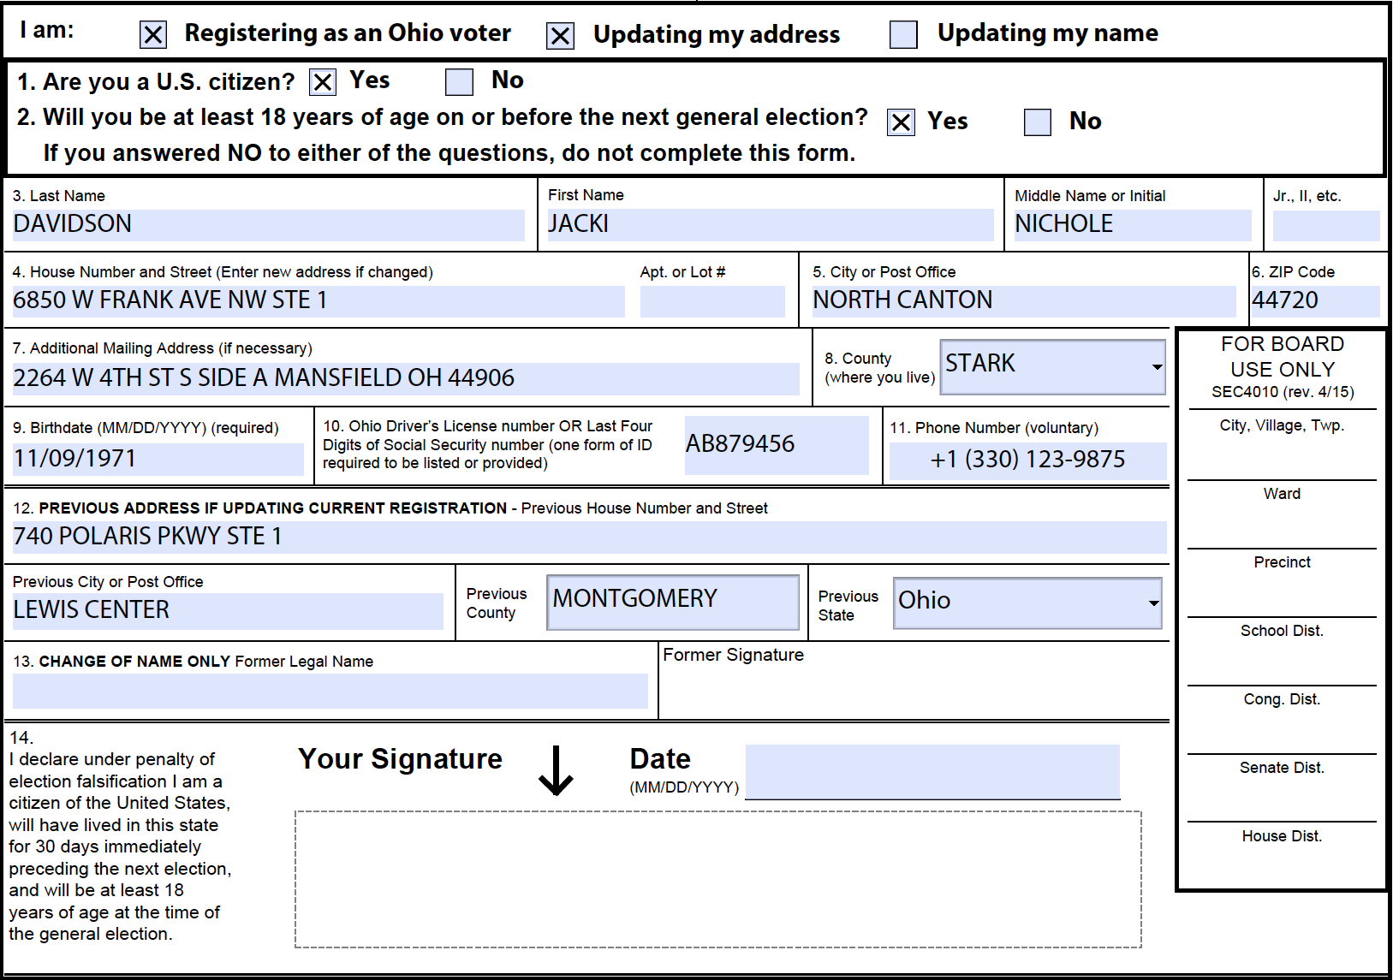
Figure 8 - Example NVRA-style form for a voter address update request
The XML for the voter registration request that contains the information exported from the form is shown below. Note that in lines 16 through 19, the <AdditionalInfo> element is being used to indicate that the voter’s language preference is English; this is needed because the XML (and JSON) schema does not include a voter-preferred language element but the application at the portal required it. Thus, <AdditionalInfo> can be used to add other elements that are required by the application but not present in the schema.

<?xml version="1.0" encoding="UTF-8"?>
<!-- DISCLAIMER: All persons and places listed below are fictitious -->
<VoterRecordsRequest xmlns:xsd="http://www.w3.org/2001/XMLSchema"
xmlns:xsi="http://www.w3.org/2001/XMLSchema-instance"
xmlns="NIST_V0_voter_records_interchange.xsd"
xsi:schemaLocation="NIST_V0_voter_records_interchange.xsd
NIST_V0_voter_records_interchange.xsd"
xmlns:addr="http://www.fgdc.gov/schemas/address/addr"
xmlns:addr_type="http://www.fgdc.gov/schemas/address/addr_type">
<GeneratedDate>2017-02-10</GeneratedDate>
<Issuer>Ohio Secretary of State</Issuer>
<TransactionId>2a642eb5-169e-4a3b-8899-adc7ea6d00d0</TransactionId>
<Type>registration</Type>
<VendorApplicationId>OLVR 2.0</VendorApplicationId>
<VoterRegistration>
<AdditionalInfo>
<Name>Language</Name>
<StringValue>en_US</StringValue>
</AdditionalInfo>
<ContactMethod>
<Type>phone</Type>
<Value>3301239875</Value>
</ContactMethod>
<ContactMethod>
<Type>email</Type>
<Value>FAKEEMAIL@AOL.COM</Value>
</ContactMethod>
<DateOfBirth>1971-11-09</DateOfBirth>
<MailingAddress>
<NumberedThoroughfareAddress_type>
<addr:CompleteAddressNumber>
<addr_type:AddressNumber>2264</addr_type:AddressNumber>
</addr:CompleteAddressNumber>
<addr:CompleteStreetName>
<addr_type:StreetNamePreDirectional>W</addr_type:StreetNamePreDirectional>
<addr_type:StreetName>4TH</addr_type:StreetName>
<addr_type:StreetNamePostType>ST</addr_type:StreetNamePostType>
<addr_type:StreetNamePostDirectional>S</addr_type:StreetNamePostDirectional>
</addr:CompleteStreetName>
<addr:CompleteSubaddress>
<addr_type:SubaddressElement>
<addr_type:SubaddressType>SIDE</addr_type:SubaddressType>
<addr_type:SubaddressIdentifier>A</addr_type:SubaddressIdentifier>
</addr_type:SubaddressElement>
</addr:CompleteSubaddress>
<addr_type:CompletePlaceName>
<addr_type:PlaceName
PlaceNameType="MunicipalJurisdiction">MANSFIELD</addr_type:PlaceName>
<addr_type:PlaceName PlaceNameType="County"/>
</addr_type:CompletePlaceName>
<addr_type:StateName>OH</addr_type:StateName>
<addr_type:ZipCode>44906</addr_type:ZipCode>
</NumberedThoroughfareAddress_type>
</MailingAddress>
<Name>
<FirstName>JACKI</FirstName>
<LastName>DAVIDSON</LastName>
<MiddleName>NICHOLE</MiddleName>
</Name>
<PreviousRegistrationAddress>
<NumberedThoroughfareAddress_type>
<addr:CompleteAddressNumber>
<addr_type:AddressNumber>740</addr_type:AddressNumber>
</addr:CompleteAddressNumber>
<addr:CompleteStreetName>
<addr_type:StreetNamePreDirectional/>
<addr_type:StreetName>POLARIS</addr_type:StreetName>
<addr_type:StreetNamePostType>PKWY</addr_type:StreetNamePostType>
<addr_type:StreetNamePostDirectional/>
</addr:CompleteStreetName>
<addr:CompleteSubaddress>
<addr_type:SubaddressElement>
<addr_type:SubaddressType>STE</addr_type:SubaddressType>
<addr_type:SubaddressIdentifier>1</addr_type:SubaddressIdentifier>
</addr_type:SubaddressElement>
</addr:CompleteSubaddress>
<addr_type:CompletePlaceName>
<addr_type:PlaceName PlaceNameType="MunicipalJurisdiction">LEWIS
CENTER</addr_type:PlaceName>
<addr_type:PlaceName PlaceNameType="County">MONTGOMERY</addr_type:PlaceName>
</addr_type:CompletePlaceName>
<addr_type:StateName>OH</addr_type:StateName>
<addr_type:ZipCode>43035</addr_type:ZipCode>
</NumberedThoroughfareAddress_type>
</PreviousRegistrationAddress>
<RegistrationAddress>
<NumberedThoroughfareAddress_type>
<addr:CompleteAddressNumber>
<addr_type:AddressNumber>6850</addr_type:AddressNumber>
</addr:CompleteAddressNumber>
<addr:CompleteStreetName>
<addr_type:StreetNamePreDirectional>W</addr_type:StreetNamePreDirectional>
<addr_type:StreetName>FRANK</addr_type:StreetName>
<addr_type:StreetNamePostType>AVE</addr_type:StreetNamePostType>
<addr_type:StreetNamePostDirectional>NW</addr_type:StreetNamePostDirectional>
</addr:CompleteStreetName>
<addr:CompleteSubaddress>
<addr_type:SubaddressElement>
<addr_type:SubaddressType>STE</addr_type:SubaddressType>
<addr_type:SubaddressIdentifier>1</addr_type:SubaddressIdentifier>
</addr_type:SubaddressElement>
</addr:CompleteSubaddress>
<addr_type:CompletePlaceName>
<addr_type:PlaceName PlaceNameType="MunicipalJurisdiction">NORTH
CANTON</addr_type:PlaceName>
<addr_type:PlaceName PlaceNameType="County">STARK </addr_type:PlaceName>
</addr_type:CompletePlaceName>
<addr_type:StateName>OH</addr_type:StateName>
<addr_type:ZipCode>44720</addr_type:ZipCode>
</NumberedThoroughfareAddress_type>
</RegistrationAddress>
<RegistrationForm>nvra</RegistrationForm>
<RegistrationMethod>voter-via-mail</RegistrationMethod>
<VoterClassification>
<Assertion>yes</Assertion>
<Type>eighteen-on-election-day</Type>
</VoterClassification>
<VoterClassification>
<Assertion>yes</Assertion>
<Type>united-states-citizen</Type>
</VoterClassification>
<VoterClassification>
<Assertion>yes</Assertion>
<OtherType>ohio-resident</OtherType>
<Type>other</Type>
</VoterClassification>
<VoterClassification>
<Assertion>yes</Assertion>
<OtherType>bmv-authorization</OtherType>
<Type>other</Type>
</VoterClassification>
<VoterId>
<AttestNoSuchId>false</AttestNoSuchId>
<StringValue>AB879456</StringValue>
<Type>drivers-license</Type>
</VoterId>
<VoterId>
<AttestNoSuchId>true</AttestNoSuchId>
<Type>ssn4</Type>
</VoterId>
</VoterRegistration>
</VoterRecordsRequest>

Example 2: NVRA-style Voter Registration Request in JSON
Figure 8 shows a fictitious NVRA-style voter registration request for Jane A. Doe in the State of Ohio using JSON.

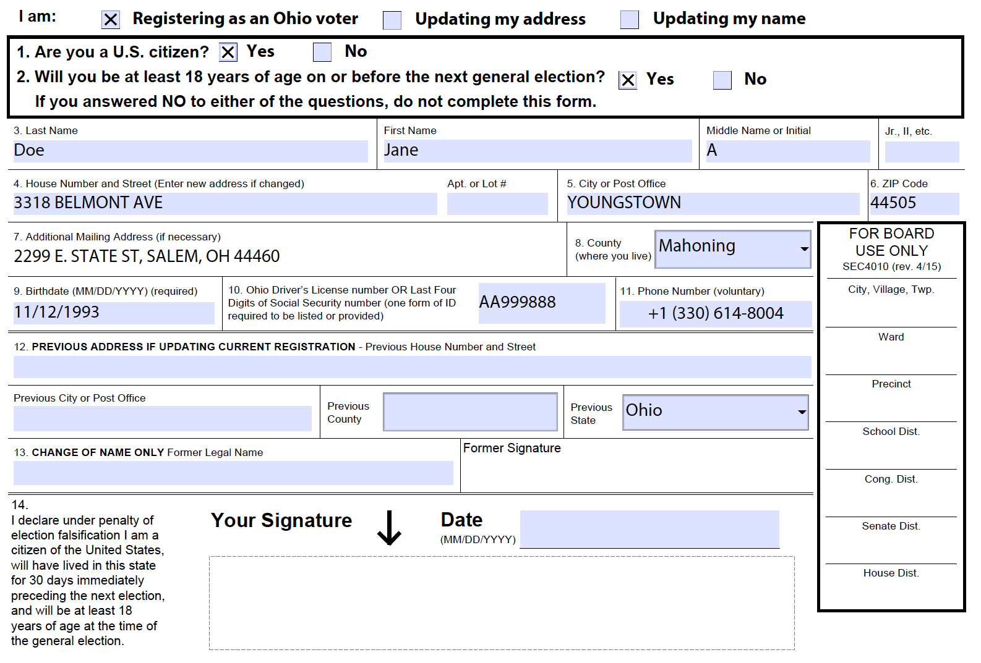
Figure 9 - Example NVRA-style form for a voter registration request

An example of the JSON statements for the voter registration request is shown below. Again, “AdditionalInfo” is being used in lines 68 through 77 to add information for elements not included in the JSON (and XML) schema, namely for the voter’s preferred language and whether the voter wishes to volunteer as a poll worker.

{
"GeneratedDate": "2017-7-30",
"Issuer": "Ohio Secretary of State",
"TransactionId": "0bb1bfd7-4316-42be-99d5-9c9e3bb9ccc0",
"Type": [
"registration"
],
"VendorApplicationId": "OLVR 2.0",
"VoterRegistration": {
"DateOfBirth": "1993-11-12T00:00:00",
"VoterId": [
{
"Type": "drivers-license",
"StringValue": "AA999888",
"AttestNoSuchId": false
},
{
"Type": "ssn4",
"StringValue": null,
"AttestNoSuchId": true
}
],
"Name": {
"FirstName": "JANE",
"MiddleName": [
"A"
],
"LastName": "DOE",
"Suffix": null
},
"VoterClassification": [
{
"Assertion": true,
"Type": "Item18onelectionday",
"OtherType": null
},
{
"Assertion": true,
"Type": "unitedstatescitizen",
"OtherType": null
},
{
"Assertion": true,
"Type": "other",
"OtherType": "swear-accuracy"
},
{
"Assertion": true,
"Type": "other",
"OtherType": "filled-on-own-behalf"
},
{
"Assertion": true,
"Type": "other",
"OtherType": "ohio-resident"
},
{
"Assertion": true,
"Type": "other",
"OtherType": "bmv-authorization"
},
{
"Assertion": true,
"Type": "other",
"OtherType": "meets-all-requirements"
}
],
"AdditionalInfo": [
{
"Name": "Language",
"StringValue": "en_US"
},
{
"Name": "IsPollWorker",
"StringValue": "false"
}
],
"ContactMethod": [
{
"Type": "phone",
"Value": "(330) 614-8004"
},
{
"Type": "email",
"Value": "JDOE@TESTEMAIL.COM"
}
],
"RegistrationAddress": {
"NumberedThoroughfareAddress_type": {
"CompleteAddressNumber": {
"AddressNumber": "3818"
},
"CompleteStreetName": {
"StreetNamePreDirectional": {
"Value": null
},
"StreetName": "BELMONT",
"StreetNamePostType": {
"Value": "AVE"
},
"StreetNamePostDirectional": {
"Value": null
}
},
"CompletePlaceName": [
{
"PlaceName": [
{
"PlaceNameTypeSpecified": true,
"PlaceNameType": "MunicipalJurisdiction",
"Value": "YOUNGSTOWN"
},
{
"PlaceNameTypeSpecified": true,
"PlaceNameType": "County",
"Value": "78"
}
]
}
],
"StateName": [
"OH"
],
"ZipCode": [
44505
],
"AddressId": 1368029993
}
},
"RegistrationMethod": "voterviamail",
"RegistrationFormSpecified": true,
"RegistrationForm": "other",
"OtherRegistrationForm": "4010",
"MailingAddress": {
"NumberedThoroughfareAddress_type": {
"CompleteAddressNumber": {
"AddressNumber": "2299"
},
"CompleteStreetName": {
"StreetNamePreDirectional": {
"Value": "E"
},
"StreetName": "STATE",
"StreetNamePostType": {
"Value": "ST"
},
"StreetNamePostDirectional": {
"Value": null
}
},
"CompletePlaceName": [
{
"PlaceName": [
{
"PlaceNameTypeSpecified": true,
"PlaceNameType": "MunicipalJurisdiction",
"Value": "SALEM"
},
{
"PlaceNameTypeSpecified": true,
"PlaceNameType": "County",
"Value": null
}
]
}
],
"StateName": [
"OH"
],
"ZipCode": [
44460
]
}
}
}
}

Example 3: NVRA-style Voter Records Response in XML

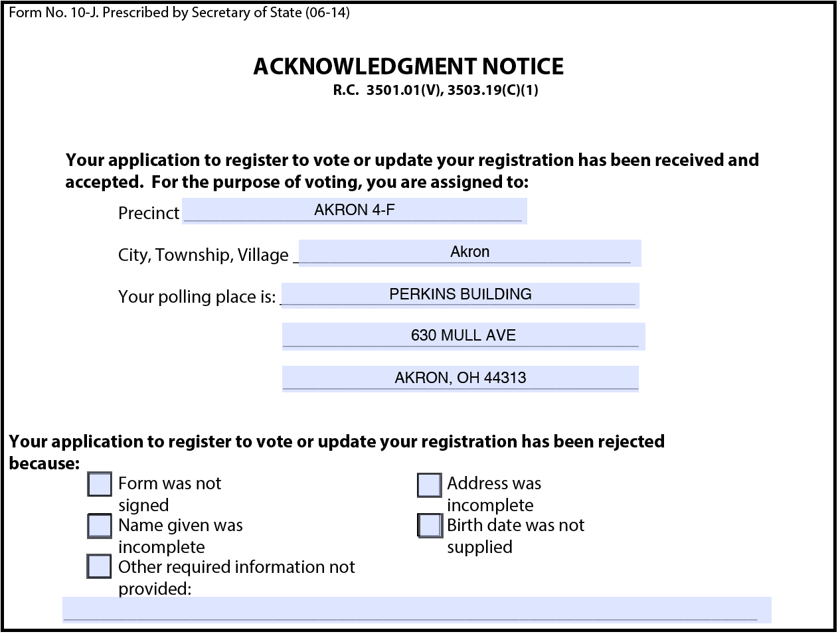
Figure 10 - Populated NVRA voter registration response form
This final example shows a fictitious digital NVRA-style registration response, successful, in the State of Ohio using XML. An example of the populated response form is shown in Figure 9. The XML for the voter registration response that contains the information used to populate the form is as follows:

<?xml version="1.0" encoding="UTF-8"?>
<!-- DISCLAIMER: All persons and places listed below are fictitious -->
<VoterRecordsResponse xsi:type="RegistrationSuccess" xmlns:xsd="http://www.w3.org/2001/XMLSchema"
xmlns:xsi="http://www.w3.org/2001/XMLSchema-instance"
xmlns="NIST_V0_voter_records_interchange.xsd"
xsi:schemaLocation="NIST_V0_voter_records_interchange.xsd
NIST_V0_voter_records_interchange.xsd"
xmlns:addr="http://www.fgdc.gov/schemas/address/addr"
xmlns:addr_type="http://www.fgdc.gov/schemas/address/addr_type">
<Action>registration-created</Action>
<Districts>
<Name>Akron</Name>
<Type>municipality</Type>
</Districts>
<EffectiveDate>2017-07-31</EffectiveDate>
<ElectionAdministration>
<ContactMethod>
<Type>phone</Type>
<Value>3306435200</Value>
</ContactMethod>
<Location>
<Address>
<GeneralAddressClass_type>
<addr:USPSGeneralDeliveryPoint>470 GRANT ST</addr:USPSGeneralDeliveryPoint>
<addr_type:PlaceStateZip>AKRON, OH 44311</addr_type:PlaceStateZip>
</GeneralAddressClass_type>
</Address>
</Location>
<Name>Summit</Name>
</ElectionAdministration>
<PollingPlace>
<Location>
<Address>
<GeneralAddressClass_type>
<addr:USPSGeneralDeliveryPoint>630 MULL AVE</addr:USPSGeneralDeliveryPoint>
<addr_type:PlaceStateZip>AKRON, OH 44313</addr_type:PlaceStateZip>
</GeneralAddressClass_type>
</Address>
</Location>
<Name>PERKINS BUILDING</Name>
<Type>polling-place</Type>
</PollingPlace>
<Locality>
<Name>AKRON 4-F</Name>
<Type>precinct</Type>
</Locality>
</VoterRecordsResponse>

Acronyms
Selected acronyms and abbreviations used in this document are defined below.
CDF | Common Data Format
EAC | Election Assistance Commission
EAVS | EAC Election Administration and Voting Survey
FIPS | Federal Information Processing Standard
FPCA | Federal Post Card Application
FWAB | Federal Write-in Absentee Ballot
JSON | JavaScript Object Notation
MMS | Multimedia Messaging Service
MIME | Multipurpose Internet Mail Extensions
NIST | National Institute of Standards and Technology
NVRA | National Voter Registration Act
OCD-ID | Open Civic Data Identifiers
OVR | Online Voter Registration
SMS | Short Message Service
SP | Special Publication
UML | Unified Modeling Language
UOCAVA | Uniform and Overseas Citizens Assistance in Voting Act
VR | Voter Registration
VVSG | Voluntary Voting Systems Guidelines
XML | eXtensible Markup Language

Glossary
Selected terms used throughout this document are defined below. In some of the definitions, there is ancillary information that is not part of the definition but helpful in understanding the definition; this ancillary information is preceded with “Note:”. Synonyms are preceded with “Syn:”.

Election official: | Any county clerk and recorder, election judge, member of a canvassing board, member of a board of county commissioners, member or secretary of a board of directors authorized to conduct public elections, representative of a governing body, or other person contracting for or engaged in the performance of election duties as required by the election code.
Electoral district: | As used in elections, administrative divisions in which voters are entitled to vote in contests that are specific to that division, such as those for state senators and delegates.
Polling place: | Location at which voters cast ballots in-person on vote-capture devices (e.g., DRE) under the supervision of poll workers usually on election day. Syn: polling station or poll. Note: A polling place is sometimes in 1-to-1 correspondence with a precinct but in some cases, may represent multiple precincts as with vote centers.
Precinct: | An election administration division corresponding to a contiguous geographic area that is the basis for determining the contests and measures on which the voters legally residing in that area are eligible to vote.
Registration assistant: | An organization whose purpose includes assisting voters in registering to vote.
Registration proxy: | An organization that submits a voter registration request on behalf of the voter, e.g., a DMV office that submits a voter registration request for a voter.
Registration witness: | An individual who witnesses a voter’s registration, i.e., the voter signing his/her registration form.
Reporting unit: | An administrative division that reports votes or to which votes are associated, e.g., state, county, city, precinct, etc.
Schema: | A file containing definitions of data elements and attributes with rules for usage, e.g., for XML.
UOCAVA voter: | From the Uniform and Overseas Citizens Assistance in Voting Act (UOCAVA); A U.S. citizen who is an active member of the Uniformed Services and the Merchant Marine, or the commissioned corps of the Public Health Service or the National Oceanic and Atmospheric Administration, their eligible family members, and U.S. citizens residing outside the United States.

References
[1] | W3C, Extensible Markup Language (XML) 1.0 (Fifth Edition), W3C Recommendation, November 26, 2008, http://www.w3.org/TR/xml/ [accessed 2/1/2016].
[2] | JavaScript Object Notation, http://www.ecma-international.org/publications/files/ECMA-ST/ECMA-404.pdf [accessed 2/1/2016].
[3] | Election Assistance Commission, Election Administration and Voting Survey, http://www.eac.gov/research/election_administration_and_voting_survey.aspx [accessed 2/1/2016].
[4] | Federal Voting Assistance Program (FVAP), Federal Post Card Application (FPCA), https://www.fvap.gov/eo/overview/materials/forms [accessed 2/1/2016].
[5] | Object Management Group (OMG), UML Specification version 1.1 (OMG document ad/97-08-11) September 22, 2011, http://omg.org/ [accessed 2/1/2016].
[6] | Federal Geographic Data Committee (FGDC), United States Thoroughfare, Landmark, And Postal Address Data Standard, http://www.fgdc.gov/standards/projects/FGDC-standards-projects/address-data/index_html [accessed 2/1/2016].
[7] | Electronic Registration Information Center (ERIC), http://www.ericstates.org/ [accessed 9/5/2017].
[8] | Election Assistance Commission, Election Administration and Voting Survey (EAVS), http://www.eac.gov [accessed 9/5/2017].
[9] | Federal Geographic Data Committee (FGDC), https://www.fgdc.gov/.
[10] | U.S. Postal Service (USPS), “Postal Addressing Standards” Publication 28, April 2010, http://pe.usps.gov/cpim/ftp/pubs/Pub28/Pub28.pdf [accessed 9/5/2017].
[11] | Open Civic Data, OCD Identifiers, http://opencivicdata.readthedocs.org/en/latest/ocdids.html [accessed 2/1/2016].
[12] | ISO 3166-1 Country Codes, https://www.iso.org/obp/ui/#search [accessed 11/08/2017].

File Download Locations
The files associated with this specification are available for download from a NIST repository, whose address is:

http://vote.nist.gov

These files are:

- This specification,
- UML model,
- XML and JSON schemas,
- Example files, and
- Validation tools.

XML Schema
<?xml version="1.0" encoding="UTF-8"?>
<xsd:schema elementFormDefault="qualified" targetNamespace="NIST_V0_voter_records_interchange.xsd" version="0.0" xmlns="NIST_V0_voter_records_interchange.xsd" xmlns:addr="http://www.fgdc.gov/schemas/address/addr"
<!-- ========== Imports ========== -->
<xsd:import namespace="http://www.fgdc.gov/schemas/address/addr" schemaLocation="https://www.fgdc.gov/schemas/address/addr.xsd"/>
<!-- ========== Roots ========== -->
<xsd:element name="VoterRecordsRequest" type="VoterRecordsRequest"/>
<xsd:element name="VoterRecordsResponse" type="VoterRecordsResponse"/>
<!-- ========== Enumerations ========== -->
<xsd:simpleType name="AssertionValue">
<xsd:restriction base="xsd:string">
<xsd:enumeration value="no"/>
<xsd:enumeration value="yes"/>
<xsd:enumeration value="unknown"/>
</xsd:restriction>
</xsd:simpleType>
<xsd:simpleType name="BallotReceiptMethod">
<xsd:restriction base="xsd:string">
<xsd:enumeration value="email"/>
<xsd:enumeration value="email-or-online"/>
<xsd:enumeration value="fax"/>
<xsd:enumeration value="mail"/>
<xsd:enumeration value="online"/>
</xsd:restriction>
</xsd:simpleType>
<xsd:simpleType name="ContactMethodType">
<xsd:restriction base="xsd:string">
<xsd:enumeration value="email"/>
<xsd:enumeration value="phone"/>
<xsd:enumeration value="other"/>
</xsd:restriction>
</xsd:simpleType>
<xsd:simpleType name="IdentifierType">
<xsd:restriction base="xsd:string">
<xsd:enumeration value="fips"/>
<xsd:enumeration value="local-level"/>
<xsd:enumeration value="national-level"/>
<xsd:enumeration value="ocd-id"/>
<xsd:enumeration value="state-level"/>
<xsd:enumeration value="other"/>
</xsd:restriction>
</xsd:simpleType>
<xsd:simpleType name="PhoneCapability">
<xsd:restriction base="xsd:string">
<xsd:enumeration value="fax"/>
<xsd:enumeration value="mms"/>
<xsd:enumeration value="sms"/>
<xsd:enumeration value="voice"/>
</xsd:restriction>
</xsd:simpleType>
<xsd:simpleType name="RegistrationError">
<xsd:restriction base="xsd:string">
<xsd:enumeration value="identity-lookup-failed"/>
<xsd:enumeration value="incomplete"/>
<xsd:enumeration value="incomplete-address"/>
<xsd:enumeration value="incomplete-birth-date"/>
<xsd:enumeration value="incomplete-name"/>
<xsd:enumeration value="incomplete-signature"/>
<xsd:enumeration value="ineligible"/>
<xsd:enumeration value="invalid-form"/>
<xsd:enumeration value="other"/>
</xsd:restriction>
</xsd:simpleType>
<xsd:simpleType name="RegistrationForm">
<xsd:restriction base="xsd:string">
<xsd:enumeration value="fpca"/>
<xsd:enumeration value="nvra"/>
<xsd:enumeration value="other"/>
</xsd:restriction>
</xsd:simpleType>
<xsd:simpleType name="RegistrationHelperType">
<xsd:restriction base="xsd:string">
<xsd:enumeration value="assistant"/>
<xsd:enumeration value="witness"/>
</xsd:restriction>
</xsd:simpleType>
<xsd:simpleType name="RegistrationMethod">
<xsd:restriction base="xsd:string">
<xsd:enumeration value="armed-forces-recruitment-office"/>
<xsd:enumeration value="motor-vehicle-office"/>
<xsd:enumeration value="other-agency-designated-by-state"/>
<xsd:enumeration value="public-assistance-office"/>
<xsd:enumeration value="registration-drive-from-advocacy-group-or-political-party"/>
<xsd:enumeration value="state-funded-agency-serving-persons-with-disabilities"/>
<xsd:enumeration value="voter-via-election-registrars-office"/>
<xsd:enumeration value="voter-via-email"/>
<xsd:enumeration value="voter-via-fax"/>
<xsd:enumeration value="voter-via-internet"/>
<xsd:enumeration value="voter-via-mail"/>
<xsd:enumeration value="unknown"/>
<xsd:enumeration value="other"/>
</xsd:restriction>
</xsd:simpleType>
<xsd:simpleType name="RegistrationProxyType">
<xsd:restriction base="xsd:string">
<xsd:enumeration value="armed-forces-recruitment-office"/>
<xsd:enumeration value="motor-vehicle-office"/>
<xsd:enumeration value="other-agency-designated-by-state"/>
<xsd:enumeration value="public-assistance-office"/>
<xsd:enumeration value="registration-drive-from-advocacy-group-or-political-party"/>
<xsd:enumeration value="state-funded-agency-serving-persons-with-disabilities"/>
<xsd:enumeration value="other"/>
</xsd:restriction>
</xsd:simpleType>
<xsd:simpleType name="RegistrationRequestType">
<xsd:annotation>
<xsd:documentation xml:lang="en">
The specific type of message being sent. Each type indicates a desired result by the system receiving the message. The meanings of each type will need to be explicitly stated.

This attribute is optional, and if not specified (or other), the required Action attribute will determine the message semantics generically.

For example: 'address update' indicates that only the voter's address should be updated on an existing voter registration.
'address update' requests would specify the 'update' RegistrationAction.
</xsd:documentation>
</xsd:annotation>
<xsd:restriction base="xsd:string">
<xsd:enumeration value="ballot-request"/>
<xsd:enumeration value="registration"/>
<xsd:enumeration value="other"/>
</xsd:restriction>
</xsd:simpleType>
<xsd:simpleType name="ReportingUnitType">
<xsd:restriction base="xsd:string">
<xsd:enumeration value="ballot-batch"/>
<xsd:enumeration value="ballot-style-area"/>
<xsd:enumeration value="borough"/>
<xsd:enumeration value="city"/>
<xsd:enumeration value="city-council"/>
<xsd:enumeration value="combined-precinct"/>
<xsd:enumeration value="congressional"/>
<xsd:enumeration value="county"/>
<xsd:enumeration value="county-council"/>
<xsd:enumeration value="drop-box"/>
<xsd:enumeration value="judicial"/>
<xsd:enumeration value="municipality"/>
<xsd:enumeration value="polling-place"/>
<xsd:enumeration value="precinct"/>
<xsd:enumeration value="school"/>
<xsd:enumeration value="special"/>
<xsd:enumeration value="split-precinct"/>
<xsd:enumeration value="state"/>
<xsd:enumeration value="state-house"/>
<xsd:enumeration value="state-senate"/>
<xsd:enumeration value="town"/>
<xsd:enumeration value="township"/>
<xsd:enumeration value="utility"/>
<xsd:enumeration value="village"/>
<xsd:enumeration value="vote-center"/>
<xsd:enumeration value="ward"/>
<xsd:enumeration value="water"/>
<xsd:enumeration value="other"/>
</xsd:restriction>
</xsd:simpleType>
<xsd:simpleType name="SignatureSource">
<xsd:restriction base="xsd:string">
<xsd:enumeration value="dmv"/>
<xsd:enumeration value="local"/>
<xsd:enumeration value="state"/>
<xsd:enumeration value="voter"/>
<xsd:enumeration value="other"/>
</xsd:restriction>
</xsd:simpleType>
<xsd:simpleType name="SignatureType">
<xsd:restriction base="xsd:string">
<xsd:enumeration value="dynamic"/>
<xsd:enumeration value="electronic"/>
<xsd:enumeration value="other"/>
</xsd:restriction>
</xsd:simpleType>
<xsd:simpleType name="SuccessAction">
<xsd:restriction base="xsd:string">
<xsd:enumeration value="address-updated"/>
<xsd:enumeration value="name-updated"/>
<xsd:enumeration value="registration-cancelled"/>
<xsd:enumeration value="registration-created"/>
<xsd:enumeration value="registration-updated"/>
<xsd:enumeration value="status-updated"/>
<xsd:enumeration value="other"/>
</xsd:restriction>
</xsd:simpleType>
<xsd:simpleType name="VoterClassificationType">
<xsd:restriction base="xsd:string">
<xsd:enumeration value="activated-national-guard"/>
<xsd:enumeration value="active-duty"/>
<xsd:enumeration value="active-duty-spouse-or-dependent"/>
<xsd:enumeration value="citizen-abroad-intent-to-return"/>
<xsd:enumeration value="citizen-abroad-return-uncertain"/>
<xsd:enumeration value="citizen-abroad-never-resided"/>
<xsd:enumeration value="deceased"/>
<xsd:enumeration value="declared-incompetent"/>
<xsd:enumeration value="eighteen-on-election-day"/>
<xsd:enumeration value="felon"/>
<xsd:enumeration value="permanently-denied"/>
<xsd:enumeration value="protected-voter"/>
<xsd:enumeration value="restored-felon"/>
<xsd:enumeration value="united-states-citizen"/>
<xsd:enumeration value="other"/>
</xsd:restriction>
</xsd:simpleType>
<xsd:simpleType name="VoterIdType">
<xsd:restriction base="xsd:string">
<xsd:enumeration value="drivers-license"/>
<xsd:enumeration value="local-voter-registration-id"/>
<xsd:enumeration value="ssn"/>
<xsd:enumeration value="ssn4"/>
<xsd:enumeration value="state-id"/>
<xsd:enumeration value="state-voter-registration-id"/>
<xsd:enumeration value="unspecified-document"/>
<xsd:enumeration value="unspecified-document-with-name-and-address"/>
<xsd:enumeration value="unspecified-document-with-photo-identification"/>
<xsd:enumeration value="unknown"/>
<xsd:enumeration value="other"/>
</xsd:restriction>
</xsd:simpleType>
<!-- ========== Interfaces Defined ========== -->
<!-- === Interface Address === -->
<xsd:group name="Address">
<xsd:choice>
<xsd:element name="CommunityAddress_type" type="addr:CommunityAddress_type"/>
<xsd:element name="FourNumberAddressRange_type" type="addr:FourNumberAddressRange_type"/>
<xsd:element name="GeneralAddressClass_type" type="addr:GeneralAddressClass_type"/>
<xsd:element name="IntersectionAddress_type" type="addr:IntersectionAddress_type"/>
<xsd:element name="LandmarkAddress_type" type="addr:LandmarkAddress_type"/>
<xsd:element name="NumberedThoroughfareAddress_type" type="addr:NumberedThoroughfareAddress_type"/>
<xsd:element name="TwoNumberAddressRange_type" type="addr:TwoNumberAddressRange_type"/>
<xsd:element name="USPSGeneralDeliveryOffice_type" type="addr:USPSGeneralDeliveryOffice_type"/>
<xsd:element name="USPSPostalDeliveryBox_type" type="addr:USPSPostalDeliveryBox_type"/>
<xsd:element name="USPSPostalDeliveryRoute_type" type="addr:USPSPostalDeliveryRoute_type"/>
<xsd:element name="UnnumberedThoroughfareAddress_type" type="addr:UnnumberedThoroughfareAddress_type"/>
</xsd:choice>
</xsd:group>
<!-- ========== Classes ========== -->
<xsd:complexType name="AdditionalInfo">
<xsd:sequence>
<xsd:element name="FileValue" type="File" minOccurs="0"/>
<xsd:element name="Name" type="xsd:string"/>
<xsd:element name="StringValue" type="xsd:string" minOccurs="0"/>
</xsd:sequence>
</xsd:complexType>
<xsd:complexType name="ContactMethod">
<xsd:sequence>
<xsd:element name="OtherType" type="xsd:string" minOccurs="0"/>
<xsd:element name="Type" type="ContactMethodType"/>
<xsd:element name="Value" type="xsd:string">
<xsd:annotation>
<xsd:documentation xml:lang="en">
The value of the ContactMethod. This will be the text value of the phone number, email address, or other mechanism. The values must be free of any formatting characters, such as parentheses or dashes for a phone number.
</xsd:documentation>
</xsd:annotation>
</xsd:element>
</xsd:sequence>
</xsd:complexType>
<xsd:complexType name="ElectionAdministration">
<xsd:sequence>
<xsd:element name="ContactMethod" type="ContactMethod" minOccurs="0" maxOccurs="unbounded"/>
<xsd:element name="Location" type="Location" minOccurs="0"/>
<xsd:element name="Name" type="xsd:string" minOccurs="0"/>
<xsd:element name="Uri" type="xsd:anyURI" minOccurs="0" maxOccurs="unbounded"/>
</xsd:sequence>
</xsd:complexType>
<xsd:complexType name="ExternalIdentifier">
<xsd:sequence>
<xsd:element name="OtherType" type="xsd:string" minOccurs="0"/>
<xsd:element name="Type" type="IdentifierType"/>
<xsd:element name="Value" type="xsd:string"/>
</xsd:sequence>
</xsd:complexType>
<xsd:complexType name="File">
<xsd:simpleContent>
<xsd:extension base="xsd:base64Binary">
<xsd:attribute name="fileName" type="xsd:string"/>
<xsd:attribute name="mimeType" type="xsd:string"/>
</xsd:extension>
</xsd:simpleContent>
</xsd:complexType>
<xsd:complexType name="Image">
<xsd:complexContent>
<xsd:extension base="File">
</xsd:extension>
</xsd:complexContent>
</xsd:complexType>
<xsd:complexType name="LatLng">
<xsd:sequence>
<xsd:element name="Latitude" type="xsd:float"/>
<xsd:element name="Longitude" type="xsd:float"/>
<xsd:element name="Source" type="xsd:string" minOccurs="0"/>
</xsd:sequence>
</xsd:complexType>
<xsd:complexType name="Location">
<xsd:sequence>
<xsd:element name="Address" minOccurs="0">
<xsd:complexType>
<xsd:sequence>
<xsd:group minOccurs="0" maxOccurs="1" ref="Address"/>
</xsd:sequence>
</xsd:complexType>
</xsd:element>
<xsd:element name="Directions" type="xsd:string" minOccurs="0"/>
<xsd:element name="LatLng" type="LatLng" minOccurs="0"/>
</xsd:sequence>
</xsd:complexType>
<xsd:complexType name="Name">
<xsd:sequence>
<xsd:element name="FirstName" type="xsd:string" minOccurs="0"/>
<xsd:element name="FullName" type="xsd:string" minOccurs="0"/>
<xsd:element name="LastName" type="xsd:string" minOccurs="0"/>
<xsd:element name="MiddleName" type="xsd:string" minOccurs="0" maxOccurs="unbounded"/>
<xsd:element name="Prefix" type="xsd:string" minOccurs="0"/>
<xsd:element name="Suffix" type="xsd:string" minOccurs="0"/>
</xsd:sequence>
</xsd:complexType>
<xsd:complexType name="Party">
<xsd:sequence>
<xsd:element name="Abbreviation" type="xsd:string" minOccurs="0"/>
<xsd:element name="ExternalIdentifier" type="ExternalIdentifier" minOccurs="0" maxOccurs="unbounded"/>
<xsd:element name="Name" type="xsd:string"/>
</xsd:sequence>
</xsd:complexType>
<xsd:complexType name="PhoneContactMethod">
<xsd:complexContent>
<xsd:extension base="ContactMethod">
<xsd:sequence>
<xsd:element name="Capability" type="PhoneCapability" minOccurs="0" maxOccurs="unbounded"/>
</xsd:sequence>
</xsd:extension>
</xsd:complexContent>
</xsd:complexType>
<xsd:complexType name="RegistrationAcknowledgement">
<xsd:complexContent>
<xsd:extension base="VoterRecordsResponse">
</xsd:extension>
</xsd:complexContent>
</xsd:complexType>
<xsd:complexType name="RegistrationHelper">
<xsd:sequence>
<xsd:element name="Address" minOccurs="0">
<xsd:complexType>
<xsd:sequence>
<xsd:group minOccurs="0" maxOccurs="1" ref="Address"/>
</xsd:sequence>
</xsd:complexType>
</xsd:element>
<xsd:element name="Name" type="Name" minOccurs="0"/>
<xsd:element name="Phone" type="PhoneContactMethod" minOccurs="0"/>
<xsd:element name="Signature" type="Signature" minOccurs="0"/>
<xsd:element name="Type" type="RegistrationHelperType"/>
</xsd:sequence>
</xsd:complexType>
<xsd:complexType name="RegistrationProxy">
<xsd:sequence>
<xsd:element name="Address" minOccurs="0">
<xsd:complexType>
<xsd:sequence>
<xsd:group minOccurs="0" maxOccurs="1" ref="Address"/>
</xsd:sequence>
</xsd:complexType>
</xsd:element>
<xsd:element name="Name" type="xsd:string" minOccurs="0"/>
<xsd:element name="OriginTransactionId" type="xsd:string" minOccurs="0"/>
<xsd:element name="OtherType" type="xsd:string" minOccurs="0"/>
<xsd:element name="Phone" type="PhoneContactMethod" minOccurs="0"/>
<xsd:element name="TimeStamp" type="xsd:date" minOccurs="0">
<xsd:annotation>
<xsd:documentation xml:lang="en">
The date this source received the request.
</xsd:documentation>
</xsd:annotation>
</xsd:element>
<xsd:element name="Type" type="RegistrationProxyType"/>
</xsd:sequence>
</xsd:complexType>
<xsd:complexType name="RegistrationRejection">
<xsd:complexContent>
<xsd:extension base="VoterRecordsResponse">
<xsd:sequence>
<xsd:element name="AdditionalDetails" type="xsd:string" minOccurs="0" maxOccurs="unbounded"/>
<xsd:element name="Error" type="RegistrationError" minOccurs="0" maxOccurs="unbounded"/>
<xsd:element name="OtherError" type="xsd:string" minOccurs="0" maxOccurs="unbounded"/>
</xsd:sequence>
</xsd:extension>
</xsd:complexContent>
</xsd:complexType>
<xsd:complexType name="RegistrationSuccess">
<xsd:complexContent>
<xsd:extension base="VoterRecordsResponse">
<xsd:sequence>
<xsd:element name="Action" type="SuccessAction" minOccurs="0" maxOccurs="unbounded"/>
<xsd:element name="District" type="ReportingUnit" minOccurs="0" maxOccurs="unbounded"/>
<xsd:element name="EffectiveDate" type="xsd:date" minOccurs="0"/>
<xsd:element name="ElectionAdministration" type="ElectionAdministration" minOccurs="0"/>
<xsd:element name="Locality" type="ReportingUnit" minOccurs="0" maxOccurs="unbounded"/>
<xsd:element name="PollingPlace" type="ReportingUnit" minOccurs="0"/>
</xsd:sequence>
</xsd:extension>
</xsd:complexContent>
</xsd:complexType>
<xsd:complexType name="ReportingUnit">
<xsd:sequence>
<xsd:element name="ExternalIdentifier" type="ExternalIdentifier" minOccurs="0" maxOccurs="unbounded"/>
<xsd:element name="IsDistricted" type="xsd:boolean" minOccurs="0"/>
<xsd:element name="Location" type="Location" minOccurs="0"/>
<xsd:element name="Name" type="xsd:string" minOccurs="0">
<xsd:annotation>
<xsd:documentation xml:lang="en">
Name of the reporting unit.
</xsd:documentation>
</xsd:annotation>
</xsd:element>
<xsd:element name="OtherType" type="xsd:string" minOccurs="0"/>
<xsd:element name="Type" type="ReportingUnitType">
<xsd:annotation>
<xsd:documentation xml:lang="en">
Type of reporting unit, e.g., state, jurisdiction, district, etc.

This field is a key into the NIST maintained registry of GpUnit types.
The key specifies the geo-political category of the locality, the type of locality, and optionally a sub-type.

If an 'Other' type or subtype is specified, then it will be defined via the OtherType value.
</xsd:documentation>
</xsd:annotation>
</xsd:element>
</xsd:sequence>
</xsd:complexType>
<xsd:complexType name="Signature">
<xsd:sequence>
<xsd:element name="Date" type="xsd:date" minOccurs="0"/>
<xsd:element name="FileValue" type="Image" minOccurs="0"/>
<xsd:element name="OtherSource" type="xsd:string" minOccurs="0"/>
<xsd:element name="OtherType" type="xsd:string" minOccurs="0"/>
<xsd:element name="Source" type="SignatureSource" minOccurs="0"/>
<xsd:element name="Type" type="SignatureType" minOccurs="0"/>
</xsd:sequence>
</xsd:complexType>
<xsd:complexType name="VoterClassification">
<xsd:sequence>
<xsd:element name="Assertion" type="AssertionValue"/>
<xsd:element name="OtherType" type="xsd:string" minOccurs="0"/>
<xsd:element name="Type" type="VoterClassificationType"/>
</xsd:sequence>
</xsd:complexType>
<xsd:complexType name="VoterId">
<xsd:sequence>
<xsd:element name="AttestNoSuchId" type="xsd:boolean" minOccurs="0"/>
<xsd:element name="DateOfIssuance" type="xsd:date" minOccurs="0"/>
<xsd:element name="FileValue" type="File" minOccurs="0"/>
<xsd:element name="OtherType" type="xsd:string" minOccurs="0"/>
<xsd:element name="StringValue" type="xsd:string" minOccurs="0"/>
<xsd:element name="Type" type="VoterIdType"/>
</xsd:sequence>
</xsd:complexType>
<xsd:complexType name="VoterRecordsRequest">
<xsd:sequence>
<xsd:element name="GeneratedDate" type="xsd:date">
<xsd:annotation>
<xsd:documentation xml:lang="en">
The date of this message's creation
</xsd:documentation>
</xsd:annotation>
</xsd:element>
<xsd:element name="Issuer" type="xsd:string" minOccurs="0"/>
<xsd:element name="OtherType" type="xsd:string" minOccurs="0"/>
<xsd:element name="TransactionId" type="xsd:string" minOccurs="0"/>
<xsd:element name="Type" type="RegistrationRequestType" maxOccurs="unbounded">
<xsd:annotation>
<xsd:documentation xml:lang="en">
The specific type of request that is being made. Each type indicates a desired result by the system receiving the message. The meanings of each type will need to be explicitly stated.

This attribute is optional, and if not specified (or other), the required Action attribute will determine the message semantics generically.

For example: 'address update' indicates that only the voter's address should be updated on an existing voter registration.
'address update' requests would specify the 'update' RegistrationAction.
</xsd:documentation>
</xsd:annotation>
</xsd:element>
<xsd:element name="VendorApplicationId" type="xsd:string" minOccurs="0"/>
<xsd:element name="VoterRegistration" type="VoterRegistration"/>
</xsd:sequence>
</xsd:complexType>
<xsd:complexType name="VoterRecordsResponse" abstract="true">
<xsd:sequence>
<xsd:element name="TransactionId" type="xsd:string" minOccurs="0"/>
</xsd:sequence>
</xsd:complexType>
<xsd:complexType name="VoterRegistration">
<xsd:sequence>
<xsd:element name="AdditionalInfo" type="AdditionalInfo" minOccurs="0" maxOccurs="unbounded"/>
<xsd:element name="BallotReceiptPreference" type="BallotReceiptMethod" minOccurs="0" maxOccurs="unbounded">
<xsd:annotation>
<xsd:documentation xml:lang="en">
The voter's preference on how to receive their ballot in order from their most preferred method to least.

This property is only used if the VoterRecordsRequest Type specifies: ballot-request.
</xsd:documentation>
</xsd:annotation>
</xsd:element>
<xsd:element name="ContactMethod" type="ContactMethod" minOccurs="0" maxOccurs="unbounded">
<xsd:annotation>
<xsd:documentation xml:lang="en">
Contact methods, listed in order of contact preference.
</xsd:documentation>
</xsd:annotation>
</xsd:element>
<xsd:element name="DateOfBirth" type="xsd:date" minOccurs="0"/>
<xsd:element name="Ethnicity" type="xsd:string" minOccurs="0"/>
<xsd:element name="Gender" type="xsd:string" minOccurs="0">
<xsd:annotation>
<xsd:documentation xml:lang="en">
Older systems may not understand values other than 'Male' or 'Female' (the only choices available on FPCA)
</xsd:documentation>
</xsd:annotation>
</xsd:element>
<xsd:element name="LastDateOfUSResidency" type="xsd:date" minOccurs="0"/>
<xsd:element name="MailForwardingAddress" minOccurs="0">
<xsd:complexType>
<xsd:sequence>
<xsd:group minOccurs="0" maxOccurs="1" ref="Address"/>
</xsd:sequence>
</xsd:complexType>
</xsd:element>
<xsd:element name="MailingAddress" minOccurs="0">
<xsd:complexType>
<xsd:sequence>
<xsd:group minOccurs="0" maxOccurs="1" ref="Address"/>
</xsd:sequence>
</xsd:complexType>
</xsd:element>
<xsd:element name="Name" type="Name"/>
<xsd:element name="OtherRegistrationForm" type="xsd:string" minOccurs="0"/>
<xsd:element name="OtherRegistrationMethod" type="xsd:string" minOccurs="0"/>
<xsd:element name="OverseasEmployer" type="xsd:string" minOccurs="0"/>
<xsd:element name="Party" type="Party" minOccurs="0"/>
<xsd:element name="PreviousName" type="Name" minOccurs="0"/>
<xsd:element name="PreviousRegistrationAddress" minOccurs="0">
<xsd:complexType>
<xsd:sequence>
<xsd:group minOccurs="0" maxOccurs="1" ref="Address"/>
</xsd:sequence>
</xsd:complexType>
</xsd:element>
<xsd:element name="PreviousSignature" type="Signature" minOccurs="0"/>
<xsd:element name="RegistrationAddress">
<xsd:complexType>
<xsd:sequence>
<xsd:group minOccurs="1" maxOccurs="1" ref="Address"/>
</xsd:sequence>
</xsd:complexType>
</xsd:element>
<xsd:element name="RegistrationAddressIsMailingAddress" type="xsd:boolean" minOccurs="0"/>
<xsd:element name="RegistrationForm" type="RegistrationForm" minOccurs="0"/>
<xsd:element name="RegistrationHelper" type="RegistrationHelper" minOccurs="0" maxOccurs="unbounded"/>
<xsd:element name="RegistrationMethod" type="RegistrationMethod"/>
<xsd:element name="RegistrationProxy" type="RegistrationProxy" minOccurs="0"/>
<xsd:element name="SelectedLanguage" type="xsd:language" minOccurs="0">
<xsd:annotation>
<xsd:documentation xml:lang="en">
The language specified by the voter, if any.
</xsd:documentation>
</xsd:annotation>
</xsd:element>
<xsd:element name="VoterClassification" type="VoterClassification" minOccurs="0" maxOccurs="unbounded"/>
<xsd:element name="VoterId" type="VoterId" minOccurs="0" maxOccurs="unbounded"/>
</xsd:sequence>
</xsd:complexType>
</xsd:schema>

JSON Schema
{
"$schema": "http://json-schema.org/draft-04/schema#",
"definitions": {
"FGDCAddressStandard.CommunityAddress_type": {
"required": [
"@type"
],
"additionalProperties": false,
"properties": {
"@type": {
"enum": [
"FGDCAddressStandard.CommunityAddress_type"
],
"type": "string"
}
},
"type": "object"
},
"FGDCAddressStandard.FourNumberAddressRange_type": {
"required": [
"@type"
],
"additionalProperties": false,
"properties": {
"@type": {
"enum": [
"FGDCAddressStandard.FourNumberAddressRange_type"
],
"type": "string"
}
},
"type": "object"
},
"FGDCAddressStandard.GeneralAddressClass_type": {
"required": [
"@type"
],
"additionalProperties": false,
"properties": {
"@type": {
"enum": [
"FGDCAddressStandard.GeneralAddressClass_type"
],
"type": "string"
}
},
"type": "object"
},
"FGDCAddressStandard.IntersectionAddress_type": {
"required": [
"@type"
],
"additionalProperties": false,
"properties": {
"@type": {
"enum": [
"FGDCAddressStandard.IntersectionAddress_type"
],
"type": "string"
}
},
"type": "object"
},
"FGDCAddressStandard.LandmarkAddress_type": {
"required": [
"@type"
],
"additionalProperties": false,
"properties": {
"@type": {
"enum": [
"FGDCAddressStandard.LandmarkAddress_type"
],
"type": "string"
}
},
"type": "object"
},
"FGDCAddressStandard.NumberedThoroughfareAddress_type": {
"required": [
"@type"
],
"additionalProperties": false,
"properties": {
"@type": {
"enum": [
"FGDCAddressStandard.NumberedThoroughfareAddress_type"
],
"type": "string"
}
},
"type": "object"
},
"FGDCAddressStandard.TwoNumberAddressRange_type": {
"required": [
"@type"
],
"additionalProperties": false,
"properties": {
"@type": {
"enum": [
"FGDCAddressStandard.TwoNumberAddressRange_type"
],
"type": "string"
}
},
"type": "object"
},
"FGDCAddressStandard.USPSGeneralDeliveryOffice_type": {
"required": [
"@type"
],
"additionalProperties": false,
"properties": {
"@type": {
"enum": [
"FGDCAddressStandard.USPSGeneralDeliveryOffice_type"
],
"type": "string"
}
},
"type": "object"
},
"FGDCAddressStandard.USPSPostalDeliveryBox_type": {
"required": [
"@type"
],
"additionalProperties": false,
"properties": {
"@type": {
"enum": [
"FGDCAddressStandard.USPSPostalDeliveryBox_type"
],
"type": "string"
}
},
"type": "object"
},
"FGDCAddressStandard.USPSPostalDeliveryRoute_type": {
"required": [
"@type"
],
"additionalProperties": false,
"properties": {
"@type": {
"enum": [
"FGDCAddressStandard.USPSPostalDeliveryRoute_type"
],
"type": "string"
}
},
"type": "object"
},
"FGDCAddressStandard.UnnumberedThoroughfareAddress_type": {
"required": [
"@type"
],
"additionalProperties": false,
"properties": {
"@type": {
"enum": [
"FGDCAddressStandard.UnnumberedThoroughfareAddress_type"
],
"type": "string"
}
},
"type": "object"
},
"VRI.AdditionalInfo": {
"required": [
"@type",
"Name"
],
"additionalProperties": false,
"properties": {
"@type": {
"enum": [
"VRI.AdditionalInfo"
],
"type": "string"
},
"FileValue": {
"oneOf": [
{
"$ref": "#/definitions/VRI.File"
},
{
"$ref": "#/definitions/VRI.Image"
}
]
},
"Name": {
"type": "string"
},
"StringValue": {
"type": "string"
}
},
"type": "object"
},
"VRI.ContactMethod": {
"required": [
"@type",
"Type",
"Value"
],
"additionalProperties": false,
"properties": {
"@type": {
"enum": [
"VRI.ContactMethod"
],
"type": "string"
},
"OtherType": {
"type": "string"
},
"Type": {
"$ref": "#/definitions/VRI.ContactMethodType"
},
"Value": {
"type": "string"
}
},
"type": "object"
},
"VRI.ElectionAdministration": {
"required": [
"@type"
],
"additionalProperties": false,
"properties": {
"@type": {
"enum": [
"VRI.ElectionAdministration"
],
"type": "string"
},
"ContactMethods": {
"items": {
"oneOf": [
{
"$ref": "#/definitions/VRI.ContactMethod"
},
{
"$ref": "#/definitions/VRI.PhoneContactMethod"
}
]
},
"minItems": 0,
"type": "array"
},
"Location": {
"$ref": "#/definitions/VRI.Location"
},
"Name": {
"type": "string"
},
"Uri": {
"items": {
"type": "string",
"format": "uri"
},
"minItems": 0,
"type": "array"
}
},
"type": "object"
},
"VRI.ExternalIdentifier": {
"required": [
"@type",
"Type",
"Value"
],
"additionalProperties": false,
"properties": {
"@type": {
"enum": [
"VRI.ExternalIdentifier"
],
"type": "string"
},
"OtherType": {
"type": "string"
},
"Type": {
"$ref": "#/definitions/VRI.IdentifierType"
},
"Value": {
"type": "string"
}
},
"type": "object"
},
"VRI.File": {
"required": [
"@type",
"Data"
],
"additionalProperties": false,
"properties": {
"@type": {
"enum": [
"VRI.File"
],
"type": "string"
},
"Data": {
"type": "string",
"format": "byte"
},
"FileName": {
"type": "string"
},
"MimeType": {
"type": "string"
}
},
"type": "object"
},
"VRI.Image": {
"required": [
"@type",
"Data"
],
"additionalProperties": false,
"properties": {
"@type": {
"enum": [
"VRI.Image"
],
"type": "string"
},
"Data": {
"type": "string",
"format": "byte"
},
"FileName": {
"type": "string"
},
"MimeType": {
"type": "string"
}
},
"type": "object"
},
"VRI.LatLng": {
"required": [
"@type",
"Latitude",
"Longitude"
],
"additionalProperties": false,
"properties": {
"@type": {
"enum": [
"VRI.LatLng"
],
"type": "string"
},
"Latitude": {
"type": "number"
},
"Longitude": {
"type": "number"
},
"Source": {
"type": "string"
}
},
"type": "object"
},
"VRI.Location": {
"required": [
"@type"
],
"additionalProperties": false,
"properties": {
"@type": {
"enum": [
"VRI.Location"
],
"type": "string"
},
"Address": {
"$ref": "#/definitions/VRI.Address"
},
"Directions": {
"type": "string"
},
"LatLng": {
"$ref": "#/definitions/VRI.LatLng"
}
},
"type": "object"
},
"VRI.Name": {
"required": [
"@type"
],
"additionalProperties": false,
"properties": {
"@type": {
"enum": [
"VRI.Name"
],
"type": "string"
},
"FirstName": {
"type": "string"
},
"FullName": {
"type": "string"
},
"LastName": {
"type": "string"
},
"MiddleName": {
"items": {
"type": "string"
},
"minItems": 0,
"type": "array"
},
"Prefix": {
"type": "string"
},
"Suffix": {
"type": "string"
}
},
"type": "object"
},
"VRI.Party": {
"required": [
"@type",
"Name"
],
"additionalProperties": false,
"properties": {
"@type": {
"enum": [
"VRI.Party"
],
"type": "string"
},
"Abbreviation": {
"type": "string"
},
"ExternalIdentifiers": {
"items": {
"$ref": "#/definitions/VRI.ExternalIdentifier"
},
"minItems": 0,
"type": "array"
},
"Name": {
"type": "string"
}
},
"type": "object"
},
"VRI.PhoneContactMethod": {
"required": [
"@type",
"Type",
"Value"
],
"additionalProperties": false,
"properties": {
"@type": {
"enum": [
"VRI.PhoneContactMethod"
],
"type": "string"
},
"Capability": {
"items": {
"$ref": "#/definitions/VRI.PhoneCapability"
},
"minItems": 0,
"type": "array"
},
"OtherType": {
"type": "string"
},
"Type": {
"$ref": "#/definitions/VRI.ContactMethodType"
},
"Value": {
"type": "string"
}
},
"type": "object"
},
"VRI.RegistrationAcknowledgement": {
"required": [
"@type"
],
"additionalProperties": false,
"properties": {
"@type": {
"enum": [
"VRI.RegistrationAcknowledgement"
],
"type": "string"
},
"Signature": {
"$ref": "#/definitions/Xmldsig.Signature"
},
"TransactionId": {
"type": "string"
}
},
"type": "object"
},
"VRI.RegistrationHelper": {
"required": [
"@type",
"Type"
],
"additionalProperties": false,
"properties": {
"@type": {
"enum": [
"VRI.RegistrationHelper"
],
"type": "string"
},
"Address": {
"$ref": "#/definitions/VRI.Address"
},
"Name": {
"$ref": "#/definitions/VRI.Name"
},
"Phone": {
"$ref": "#/definitions/VRI.PhoneContactMethod"
},
"Signature": {
"$ref": "#/definitions/VRI.Signature"
},
"Type": {
"$ref": "#/definitions/VRI.RegistrationHelperType"
}
},
"type": "object"
},
"VRI.RegistrationProxy": {
"required": [
"@type",
"Type"
],
"additionalProperties": false,
"properties": {
"@type": {
"enum": [
"VRI.RegistrationProxy"
],
"type": "string"
},
"Address": {
"$ref": "#/definitions/VRI.Address"
},
"Name": {
"type": "string"
},
"OriginTransactionId": {
"type": "string"
},
"OtherType": {
"type": "string"
},
"Phone": {
"$ref": "#/definitions/VRI.PhoneContactMethod"
},
"TimeStamp": {
"type": "string",
"format": "date"
},
"Type": {
"$ref": "#/definitions/VRI.RegistrationProxyType"
}
},
"type": "object"
},
"VRI.RegistrationRejection": {
"required": [
"@type"
],
"additionalProperties": false,
"properties": {
"@type": {
"enum": [
"VRI.RegistrationRejection"
],
"type": "string"
},
"AdditionalDetails": {
"items": {
"type": "string"
},
"minItems": 0,
"type": "array"
},
"Error": {
"items": {
"$ref": "#/definitions/VRI.RegistrationError"
},
"minItems": 0,
"type": "array"
},
"OtherError": {
"items": {
"type": "string"
},
"minItems": 0,
"type": "array"
},
"Signature": {
"$ref": "#/definitions/Xmldsig.Signature"
},
"TransactionId": {
"type": "string"
}
},
"type": "object"
},
"VRI.RegistrationSuccess": {
"required": [
"@type"
],
"additionalProperties": false,
"properties": {
"@type": {
"enum": [
"VRI.RegistrationSuccess"
],
"type": "string"
},
"Action": {
"items": {
"$ref": "#/definitions/VRI.SuccessAction"
},
"minItems": 0,
"type": "array"
},
"District": {
"items": {
"$ref": "#/definitions/VRI.ReportingUnit"
},
"minItems": 0,
"type": "array"
},
"EffectiveDate": {
"type": "string",
"format": "date"
},
"ElectionAdministration": {
"$ref": "#/definitions/VRI.ElectionAdministration"
},
"Locality": {
"items": {
"$ref": "#/definitions/VRI.ReportingUnit"
},
"minItems": 0,
"type": "array"
},
"PollingPlace": {
"$ref": "#/definitions/VRI.ReportingUnit"
},
"Signature": {
"$ref": "#/definitions/Xmldsig.Signature"
},
"TransactionId": {
"type": "string"
}
},
"type": "object"
},
"VRI.ReportingUnit": {
"required": [
"@type",
"Type"
],
"additionalProperties": false,
"properties": {
"@type": {
"enum": [
"VRI.ReportingUnit"
],
"type": "string"
},
"ExternalIdentifiers": {
"items": {
"$ref": "#/definitions/VRI.ExternalIdentifier"
},
"minItems": 0,
"type": "array"
},
"IsDistricted": {
"type": "boolean"
},
"Location": {
"$ref": "#/definitions/VRI.Location"
},
"Name": {
"type": "string"
},
"OtherType": {
"type": "string"
},
"Type": {
"$ref": "#/definitions/VRI.ReportingUnitType"
}
},
"type": "object"
},
"VRI.Signature": {
"required": [
"@type"
],
"additionalProperties": false,
"properties": {
"@type": {
"enum": [
"VRI.Signature"
],
"type": "string"
},
"Date": {
"type": "string",
"format": "date"
},
"FileValue": {
"$ref": "#/definitions/VRI.Image"
},
"OtherSource": {
"type": "string"
},
"OtherType": {
"type": "string"
},
"Source": {
"$ref": "#/definitions/VRI.SignatureSource"
},
"Type": {
"$ref": "#/definitions/VRI.SignatureType"
}
},
"type": "object"
},
"VRI.VoterClassification": {
"required": [
"@type",
"Assertion",
"Type"
],
"additionalProperties": false,
"properties": {
"@type": {
"enum": [
"VRI.VoterClassification"
],
"type": "string"
},
"Assertion": {
"$ref": "#/definitions/VRI.AssertionValue"
},
"OtherType": {
"type": "string"
},
"Type": {
"$ref": "#/definitions/VRI.VoterClassificationType"
}
},
"type": "object"
},
"VRI.VoterId": {
"required": [
"@type",
"Type"
],
"additionalProperties": false,
"properties": {
"@type": {
"enum": [
"VRI.VoterId"
],
"type": "string"
},
"AttestNoSuchId": {
"type": "boolean"
},
"DateOfIssuance": {
"type": "string",
"format": "date"
},
"FileValue": {
"oneOf": [
{
"$ref": "#/definitions/VRI.File"
},
{
"$ref": "#/definitions/VRI.Image"
}
]
},
"OtherType": {
"type": "string"
},
"StringValue": {
"type": "string"
},
"Type": {
"$ref": "#/definitions/VRI.VoterIdType"
}
},
"type": "object"
},
"VRI.VoterRecordsRequest": {
"required": [
"@type",
"GeneratedDate",
"Type",
"VoterRegistration"
],
"additionalProperties": false,
"properties": {
"@type": {
"enum": [
"VRI.VoterRecordsRequest"
],
"type": "string"
},
"GeneratedDate": {
"type": "string",
"format": "date"
},
"Issuer": {
"type": "string"
},
"OtherType": {
"type": "string"
},
"Signature": {
"$ref": "#/definitions/Xmldsig.Signature"
},
"TransactionId": {
"type": "string"
},
"Type": {
"items": {
"$ref": "#/definitions/VRI.RegistrationRequestType"
},
"minItems": 1,
"type": "array"
},
"VendorApplicationId": {
"type": "string"
},
"VoterRegistration": {
"$ref": "#/definitions/VRI.VoterRegistration"
}
},
"type": "object"
},
"VRI.VoterRegistration": {
"required": [
"@type",
"RegistrationAddress",
"RegistrationMethod",
"Name"
],
"additionalProperties": false,
"properties": {
"@type": {
"enum": [
"VRI.VoterRegistration"
],
"type": "string"
},
"AdditionalInfos": {
"items": {
"$ref": "#/definitions/VRI.AdditionalInfo"
},
"minItems": 0,
"type": "array"
},
"BallotReceiptPreference": {
"items": {
"$ref": "#/definitions/VRI.BallotReceiptMethod"
},
"minItems": 0,
"type": "array"
},
"ContactMethods": {
"items": {
"oneOf": [
{
"$ref": "#/definitions/VRI.ContactMethod"
},
{
"$ref": "#/definitions/VRI.PhoneContactMethod"
}
]
},
"minItems": 0,
"type": "array"
},
"DateOfBirth": {
"type": "string",
"format": "date"
},
"Ethnicity": {
"type": "string"
},
"Gender": {
"type": "string"
},
"LastDateOfUSResidency": {
"type": "string",
"format": "date"
},
"MailForwardingAddress": {
"$ref": "#/definitions/VRI.Address"
},
"MailingAddress": {
"$ref": "#/definitions/VRI.Address"
},
"Name": {
"$ref": "#/definitions/VRI.Name"
},
"OtherRegistrationForm": {
"type": "string"
},
"OtherRegistrationMethod": {
"type": "string"
},
"OverseasEmployer": {
"type": "string"
},
"Party": {
"$ref": "#/definitions/VRI.Party"
},
"PreviousName": {
"$ref": "#/definitions/VRI.Name"
},
"PreviousRegistrationAddress": {
"$ref": "#/definitions/VRI.Address"
},
"PreviousSignature": {
"$ref": "#/definitions/VRI.Signature"
},
"RegistrationAddress": {
"$ref": "#/definitions/VRI.Address"
},
"RegistrationAddressIsMailingAddress": {
"type": "boolean"
},
"RegistrationForm": {
"$ref": "#/definitions/VRI.RegistrationForm"
},
"RegistrationHelpers": {
"items": {
"$ref": "#/definitions/VRI.RegistrationHelper"
},
"minItems": 0,
"type": "array"
},
"RegistrationMethod": {
"$ref": "#/definitions/VRI.RegistrationMethod"
},
"RegistrationProxy": {
"$ref": "#/definitions/VRI.RegistrationProxy"
},
"SelectedLanguage": {
"type": "string"
},
"Signature": {
"$ref": "#/definitions/VRI.Signature"
},
"VoterClassifications": {
"items": {
"$ref": "#/definitions/VRI.VoterClassification"
},
"minItems": 0,
"type": "array"
},
"VoterIds": {
"items": {
"$ref": "#/definitions/VRI.VoterId"
},
"minItems": 0,
"type": "array"
}
},
"type": "object"
},
"VRI.AssertionValue": {
"enum": [
"no",
"unknown",
"yes"
],
"type": "string"
},
"VRI.BallotReceiptMethod": {
"enum": [
"email",
"email-or-online",
"fax",
"mail",
"online"
],
"type": "string"
},
"VRI.ContactMethodType": {
"enum": [
"email",
"other",
"phone"
],
"type": "string"
},
"VRI.IdentifierType": {
"enum": [
"fips",
"local-level",
"national-level",
"ocd-id",
"other",
"state-level"
],
"type": "string"
},
"VRI.PhoneCapability": {
"enum": [
"fax",
"mms",
"sms",
"voice"
],
"type": "string"
},
"VRI.RegistrationError": {
"enum": [
"identity-lookup-failed",
"incomplete",
"incomplete-address",
"incomplete-birth-date",
"incomplete-name",
"incomplete-signature",
"ineligible",
"invalid-form",
"other"
],
"type": "string"
},
"VRI.RegistrationForm": {
"enum": [
"fpca",
"nvra",
"other"
],
"type": "string"
},
"VRI.RegistrationHelperType": {
"enum": [
"assistant",
"witness"
],
"type": "string"
},
"VRI.RegistrationMethod": {
"enum": [
"armed-forces-recruitment-office",
"motor-vehicle-office",
"other",
"other-agency-designated-by-state",
"public-assistance-office",
"registration-drive-from-advocacy-group-or-political-party",
"state-funded-agency-serving-persons-with-disabilities",
"unknown",
"voter-via-election-registrars-office",
"voter-via-email",
"voter-via-fax",
"voter-via-internet",
"voter-via-mail"
],
"type": "string"
},
"VRI.RegistrationProxyType": {
"enum": [
"armed-forces-recruitment-office",
"motor-vehicle-office",
"other",
"other-agency-designated-by-state",
"public-assistance-office",
"registration-drive-from-advocacy-group-or-political-party",
"state-funded-agency-serving-persons-with-disabilities"
],
"type": "string"
},
"VRI.RegistrationRequestType": {
"enum": [
"ballot-request",
"other",
"registration"
],
"type": "string"
},
"VRI.ReportingUnitType": {
"enum": [
"ballot-batch",
"ballot-style-area",
"borough",
"city",
"city-council",
"combined-precinct",
"congressional",
"county",
"county-council",
"drop-box",
"judicial",
"municipality",
"other",
"polling-place",
"precinct",
"school",
"special",
"split-precinct",
"state",
"state-house",
"state-senate",
"town",
"township",
"utility",
"village",
"vote-center",
"ward",
"water"
],
"type": "string"
},
"VRI.SignatureSource": {
"enum": [
"dmv",
"local",
"other",
"state",
"voter"
],
"type": "string"
},
"VRI.SignatureType": {
"enum": [
"dynamic",
"electronic",
"other"
],
"type": "string"
},
"VRI.SuccessAction": {
"enum": [
"address-updated",
"name-updated",
"other",
"registration-cancelled",
"registration-created",
"registration-updated",
"status-updated"
],
"type": "string"
},
"VRI.VoterClassificationType": {
"enum": [
"activated-national-guard",
"active-duty",
"active-duty-spouse-or-dependent",
"citizen-abroad-intent-to-return",
"citizen-abroad-never-resided",
"citizen-abroad-return-uncertain",
"deceased",
"declared-incompetent",
"eighteen-on-election-day",
"felon",
"other",
"permanently-denied",
"protected-voter",
"restored-felon",
"united-states-citizen"
],
"type": "string"
},
"VRI.VoterIdType": {
"enum": [
"drivers-license",
"local-voter-registration-id",
"other",
"ssn",
"ssn4",
"state-id",
"state-voter-registration-id",
"unknown",
"unspecified-document",
"unspecified-document-with-name-and-address",
"unspecified-document-with-photo-identification"
],
"type": "string"
},
"VRI.Address": {
"required": [
"@type"
],
"additionalProperties": false,
"properties": {
"@type": {
"enum": [
"VRI.Address"
],
"type": "string"
}
},
"type": "object"
},
"Xmldsig.Signature": {
"required": [
"@type"
],
"additionalProperties": false,
"properties": {
"@type": {
"enum": [
"Xmldsig.Signature"
],
"type": "string"
}
},
"type": "object"
}
},
"oneOf": [
{
"$ref": "#/definitions/VRI.VoterRecordsRequest"
},
{
"$ref": "#/definitions/VRI.VoterRecordsResponse"
}
]
}

See https://en.wikipedia.org/wiki/CamelCase.
A future version of this schema may incorporate a registry of election data-related codes.

